EMBARGO 01/03/19

XXIO REVEALS THE ALL-NEW XXIO PRIME:
INDULGE IN DISTANCE
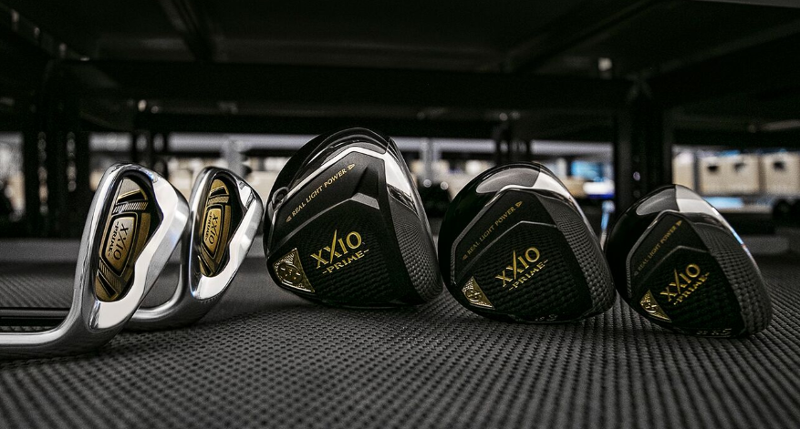

XXIO® Europe, March 1st, 2019 - XXIO®, a global leader in premium lightweight golf equipment, introduces the all-new XXIO Prime range featuring easy distance and easy accuracy for moderate swing speed golfers. The new XXIO Prime officially launches in Continental Europe from the beginning of March 2019.

“XXIO Prime is, quite frankly, the most unique and beneficial product ever available to moderate swing speed players. Period,” said Lionel Caron, Vice President of XXIO Europe. “People might think that is marketing hype, but they simply haven’t hit Prime yet.”

XXIO PRIME WOODS

The new XXIO Prime Woods feature a redesigned hosel structure and reduced stiffness at the tip of the driver shaft, making it easier for moderate swing speed players to shut the face at impact for longer, straighter drives.

Also, the new XXIO Prime Woods are lighter, making them faster while still remaining extremely easy to swing. A new forged cup face, made from Super-TIX® PLUS Titanium, is thinner, lighter and stronger for maximum COR across the entire face for more ball speed and enhanced distance.

“The speed increases, higher launch angles, and draw bias of the new Prime will show immediate results from swing one,” Thiry said. “It’s legit lightweight power for the players that absolutely need it the most.”

Key Technologies:
- Super-Tix Plus Forged Titanium Cup Face: Forged from Super-TIX® PLUS Titanium, a lightweight yet high-strength alloy, the new Cup Face greatly increases distance performance thanks to a hotter sweet spot that’s noticeably larger than the previous models.
- Unprecedented Lightweight Construction: The SP-1000 Shaft, with TORAYCA® T1100G carbon fiber and NANOALLOY resin, is strong yet extremely lightweight. That, along with weight savings in the grip and club head, produces woods that are remarkably fast and remarkably easy to swing.
- Groundbreaking Forgiveness Features: With an expanded toe and narrowed heel, a tungsten-nickel inner weight that is low and deep, a lighter hosel repositioned closer to the center of the face, and finally, reduced stiffness at the tip of the shaft, this is our most forgiving suite of XXIO Prime Woods.

XXIO PRIME HYBRIDS AND IRONS

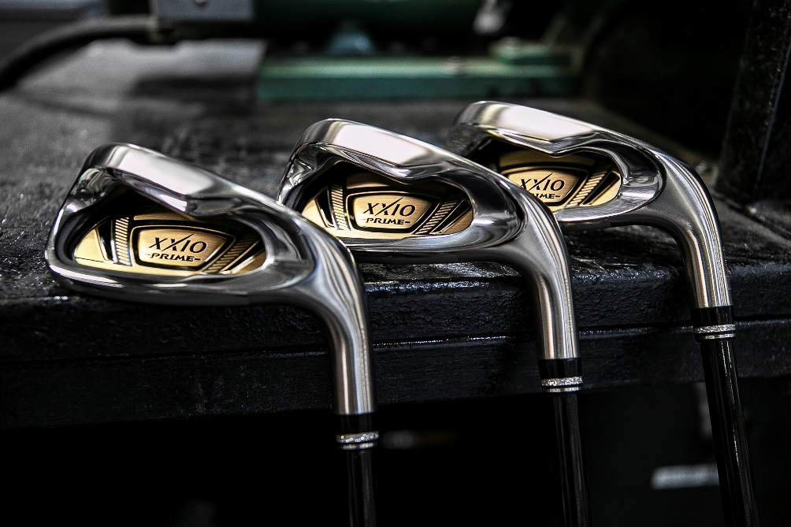

Reach more greens in fewer shots with new XXIO Prime Hybrids. With an expanded COR across the face, a lower center of gravity, and a straighter ball flight, Prime Hybrids greatly enhance distance and ball speed from anywhere on the course.

Meanwhile, stick it close with new XXIO Prime Irons, providing more distance, more stopping power and a higher launch. Featuring a forged Super-TIX® PLUS Titanium face and CNC milled Speed Grove, new Prime Irons increase ball speed across the face for easier distance and easier accuracy.

Key Technologies:
- Forged Maraging Steel Cup Face: Forged from Maraging Steel – a lightweight yet high-strength allow – the new Cup Face in the Prime Hybrids greatly increases distance performance thanks to a hotter sweet spot that is noticeably larger than the previous models.

- Super-Tix Plus Titanium Face with Speed Groove: Made from Super-TIX® PLUS Titanium – a lightweight yet high-strength alloy – the new iron faces also feature a CNC milled speed grove that greatly increases COR for a larger, hotter sweet spot that improves ball speed for enhanced distance.
- Unprecedented Lightweight Construction: The SP-1000 Shaft, with TORAYCA® T1100G carbon fiber and NANOALLOY resin, is strong yet extremely lightweight. That, along with weight savings in the grip and club head, produces hybrids and irons that are remarkably fast and remarkably easy to swing.
- Groundbreaking Forgiveness Features: With an expanded toe and narrowed heel, plus a crown step that moves weight low and deep, this is our most forgiving suite of Prime Hybrids. Similarly, with two high-density tungsten nickel sole weights and an overall profile that is 3mm shorter than the previous model, this is our most forgiving suite of Prime Irons.

“The XXIO brand continues to grow and continues to impress the moderate swing speed men and women that we believe are the lifeblood of the sport,” Lionel Caron said. “Those players seem to be responding to our focus, and moving forward, we’ll keep the focus on those core players and we’ll remain bullish on our prospects for continued success.”

CLICK BELOW for additional product images, the XXIO Prime Product Manual and to learn more about the latest offerings from XXIO.
DRIVER
FAIRWAY
HYBRIDOS
HIERROS

XXIO Prime officially launches in Continental Europe at the beginning of March 2019 with the following suggested retail prices:

Single graphite Iron: €349, CHF 289, SEK 3,499
Prime Hybrids: €429: CHF 479 SEK 4,299
Prime Fairway Woods: €649, CHF €719, SEK 6,490
Prime Driver: €999, CHF 1,099, SEK 9,999

For more detailed information on all of XXIO’s offerings visit www.xxio.eu

Follow XXIO on social media:
Facebook: @XXIOEurope
Twitter: @XXIOEurope

For additional information, imagery and content please contact James Lovett at Front 9 Group.

Email: James@front9group.com
Tel: +44 (0) 7885599932

ABOUT XXIO®:
Based in Huntington Beach, CA, XXIO®, is part of the Sumitomo Rubber Industries, Ltd. family and enjoys a strong presence on competitive tours worldwide. The professional staff includes players such as Ernie Els and Inbee Park, as well as many others. XXIO®, with their long-standing tradition of premium golf clubs in Japan, brings the #1 golf brand in Japan to America. XXIO® is committed to providing "Tour-proven, premium golf equipment to passionate golfers seeking to improve their performance while enhancing their experience playing the game of golf.” For more information, please contact Noelle Zavaleta at (714) 889-5853 or visit xxiousa.com.

