New XXIO Prime Fairway

Product Name: New XXIO Prime Fairway woods

Product Intro Date: 16th November 2016

Product At Retail Date: 14.12.2016

Product Head-liner: Longer, Higher, Stunning Prime
Pricing: SRP: Euro: 649,99 CHF: 714,99 SEK: 5999,00

Product Introduction:
To help you reach a new level of distance performance, xxio introduces the new xxio prime series. featuring advanced lightweight construction for faster head speed, a new head design for faster ball speed and powerful draw-biased performance, xxio prime is easy to hit with rewarding results

Features & Benefits

Higher launch and 3.4 yards more distance compared to the previous model
1. New thicker, full titanium cup face for improved repulsion performance across the entire club face
The new Full Titanium Cup Face is thicker by 0.5 mm than the previous model and has expanded the sweet spot which creates high COR area and greater flight distance compared to the previous model.
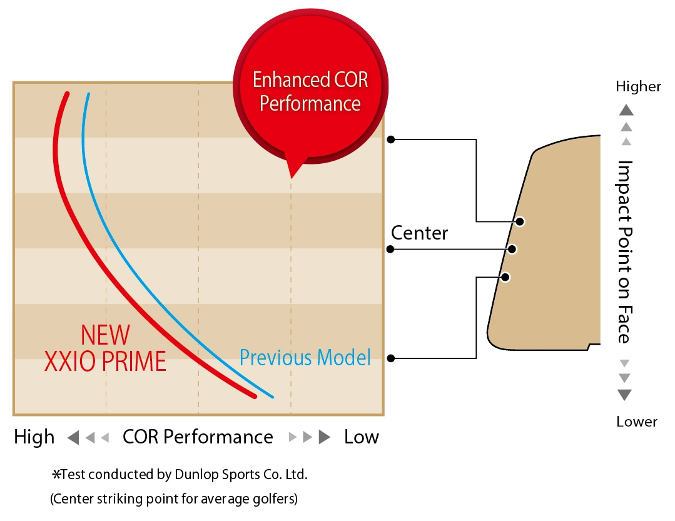
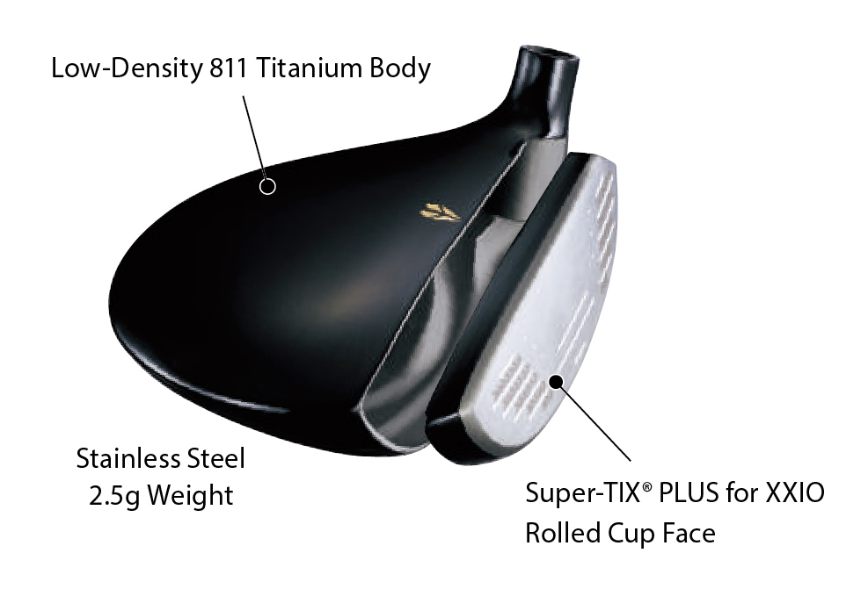

2．Shallow-back shape and titanium construction provide a lower and deeper CG for higher launch angle.
The shallow-back shape and titanium construction of the head promote a lower and deeper CG. Compared to the previous model, it promotes significantly better launch.

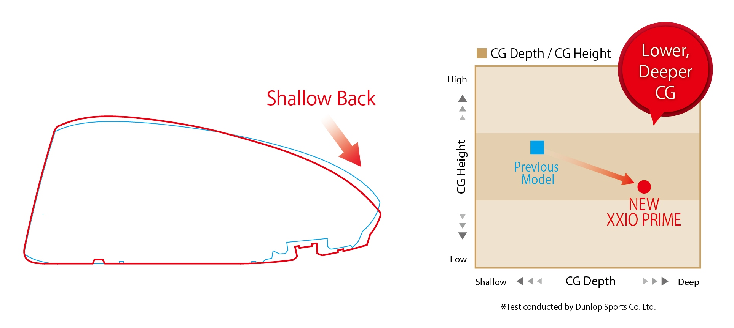

Specifications
Head material
Face: Titanium (Super-TIX® PLUS for XXIO)
Body: 8-2 titanium + SUS weight
Construction
Face: Forged
Body: Vacuum precision casting
Finish
Gold ion plating + high-gloss metallic coating; mirror + satin + bead-shot finish;
Badge: Gold
Grip
XXIO Prime original full rubber grip (with logo)
Shaft
Model | Flex | Kick point | Weight＊ | Torque
SP-900 carbon shaft | SR | middle | 39 | 6.4
 | R | middle | 38 | 6.5
 | R2 | middle | 38 | 6.6
*Weight indicates weight when fully assembled
Standard model specifications
Fairway | #3 | #5 | #7 | #9
Loft Angle (°) | 15.0 | 18.0 | 21.0 | 24.0
Lie Angle (°) | 58.0 | 59.0 | 59.5 | 60.0
Head Volume (cm³) | 188 | 166 | 157 | 144
Club Length (in) | 43.0 | 42.0 | 41.5 | 41.0
Swing Weight | D2
Club Weight* (g) R | 273 | 281 | 285 | 290
Line-up by proper model
Loft Angle | #3 | #5 | #7 | #9
SR | ○ | ○
R | ○ | ○ | ○ | ○
R2 | ○ | ○ | ○ | ○

