Media Embargo: 29th July 2019

CLEVELAND GOLF INTRODUCES THE CLEVELAND CBX 2, PUT FORGIVENESS IN YOUR SHORT GAME

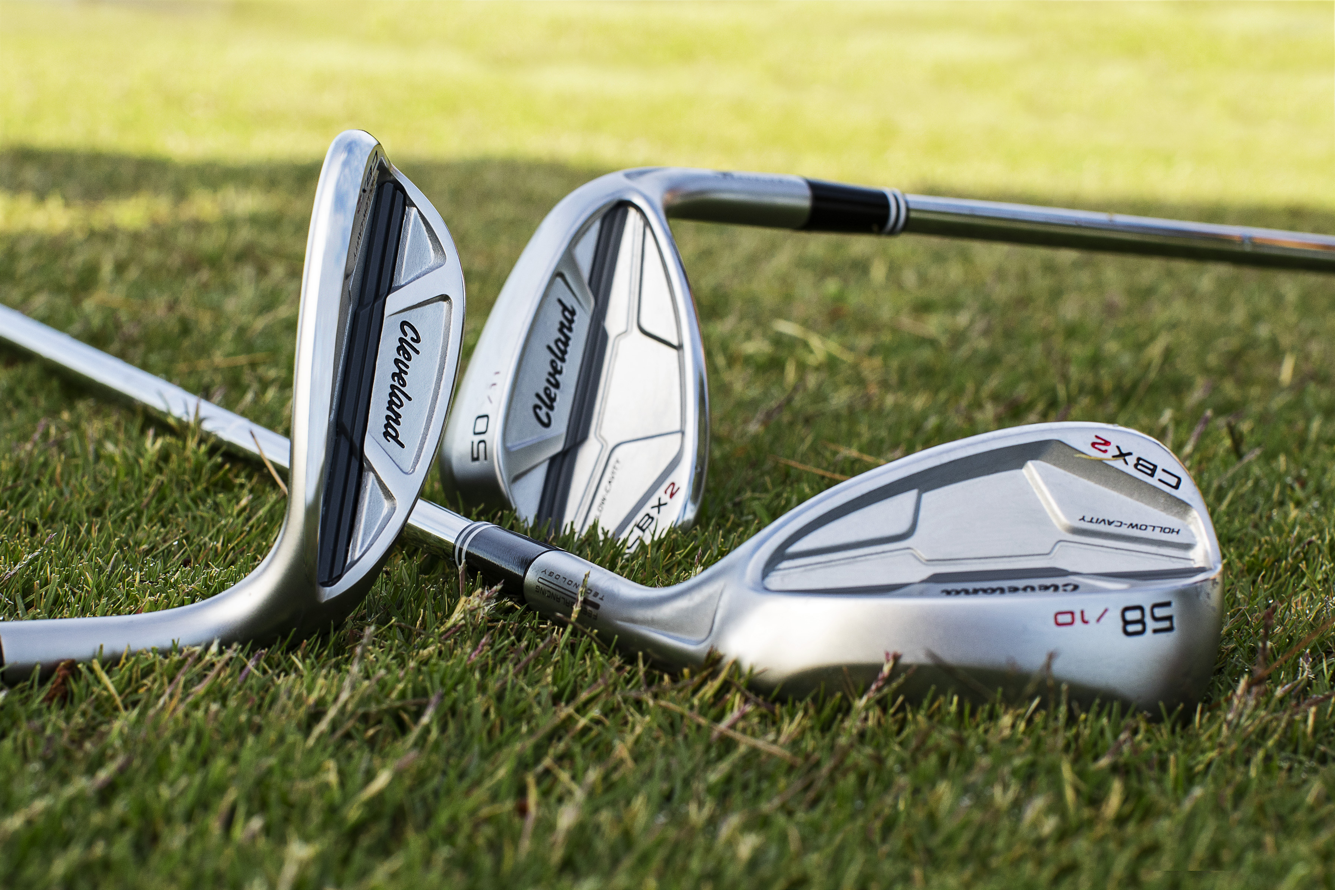
SAINT JEAN DE LUZ, France – 29th July 2019 – Cleveland Golf is proud to announce the release of the Cleveland CBX 2 wedge. Built for the vast number of golfers playing cavity back irons, the Cleveland CBX 2 offers spin, control and all the forgiveness you need. Cleveland’s CBX 2 will launch in Continental Europe on the 15th September 2019.

The Cleveland CBX 2 is a new perspective on wedge design. For far too long, wedges have been stuck in a top down approach of designing for the world’s best players at the expense of the many everyday golfers who define the sport.

With the Cleveland CBX 2, Cleveland Golf designed a forgiving, cavity back wedge built for the everyday player. While it still features tour wedge technologies that Cleveland Golf is renowned for, the Cleveland CBX 2 offers additional forgiveness to help serious golfers upgrade their short game.

“The short game is critical to playing your best golf, and playing wedges designed for your game – and the shots you like to hit – is key,” said Lionel Caron, President Continental Europe. “That’s why Cleveland CBX 2 wedges were created. They make the short game easier and more forgiving for the majority of golfers out there playing game-improvement equipment.”

Cleveland CBX 2 features a new Hollow-Cavity design with a hollow chamber near the heel and a heavy weight placed in the toe. This unique structure maximizes MOI and perimeter weighting for unrivaled short game forgiveness, while still maintaining a sleek, attractive profile at address.

Additionally, the Cleveland CBX 2 offers the latest iteration of Feel Balancing Technology that achieves a new milestone: a toe-biased center of gravity. Combined with a Gelback TPU Insert for vibration reduction, Cleveland’s CBX 2 provides a soft, satisfying feel and crisp feedback at impact.

“The Cleveland CBX 2 gives you 25% more shots on the sweet spot,” said Dustin Brekke, Engineering Manager, Research and Development. “This helps you hit better shots, but also drastically improves feel at impact.”

With Cleveland CBX 2, three distinct sole grind offerings arranged by loft deliver more versatility to execute any short game shot. Meanwhile, a staple of Cleveland’s wedge philosophy is spin. Cleveland CBX 2 features fourth generation Rotex Face Technology that delivers the sharpest Tour Zip Grooves, laser milling and aggressive face milling for maximum spin and short game control.

“It’s remarkable seeing the performance improvements when golfers switch to the extra forgiveness, better sole designs, and overall weighting that blends perfectly with their cavity back irons,” Caron said.
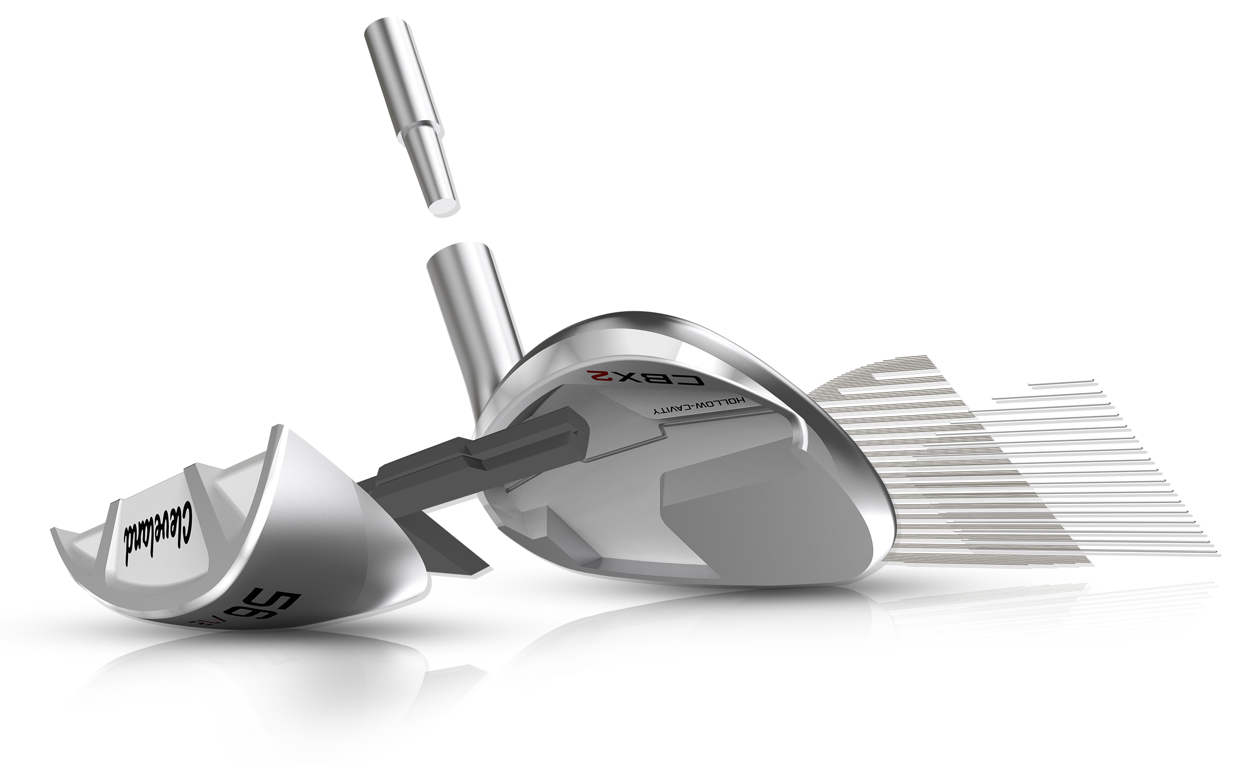
Key Innovations Inside the Cleveland CBX 2:

- Hollow-Cavity Design: With a hollow chamber near the heel and a heavy weight placed in the toe, the hollow-cavity design maximizes MOI and perimeter weighting for unprecedented short game forgiveness.
- Dynamic Sole: Shot-making is simplified with three specialized sole grinds, specifically arranged by loft, to provide all the versatility needed to execute any short game shot.
- Feel Balancing and Gelback Technologies: Enhanced Feel Balancing Technology along with a Gelback TPU Insert reduces vibration for a pure feel at impact.
- Rotex Face Technology: Fourth generation Rotex Face Technology delivers our sharpest Tour Zip Grooves and most aggressive face milling for maximum spin and short game control.

Cleveland’s CBX 2 wedges are offered in a variety of different lofts and sole grinds. The V-Shaped Sole grind is offered in 46°-52° lofts. Meanwhile, the S-Shaped Sole grind is offered in 54° and 56° lofts, while the C-Shaped Sole grind is offered in 58° and 60° lofts. The wedges are available in left and right-handed options. The Cleveland CBX 2 wedges are priced at €149,99/165 CHF/1490 SEK for Men’s Steel and Women’s and €159.99/175 CHF/1590 SEK for Men’s and Lady’s Graphite.

For high-resolution images, the Cleveland CBX 2 product manual, and other assets CLICK HERE.

For more detailed information on the Cleveland CBX 2, please visit: www.clevelandgolf.eu

ABOUT Cleveland® Golf:
Based in Huntington Beach, CA, Cleveland® Golf is part of the Sumitomo Rubber Industries, Ltd. family and enjoys a strong presence on competitive tours worldwide. Their professional staffs include players such as Graeme McDowell, Keegan Bradley, Hideki Matsuyama, Inbee Park, as well as many others. Cleveland® Golf, founded in 1979, is a leading equipment manufacturer specializing in short game technologies and solutions that benefit all golfers. Cleveland® Golf remains steadfastly committed to providing "Tour proven, premium golf equipment to passionate golfers seeking to improve their performance while enhancing their experience playing the game of golf."

