XXIO Premium Royal Gold

Product Name: New XXIO Premium Royal Gold

Product Intro Date: March 2018

Product At Retail Date: March 2018

Product Head-liner: High quality pearlescent look with tremendous distance and very soft feel at impact Enjoy high quality golf with XXIO PREMIUM

Features & Benefits
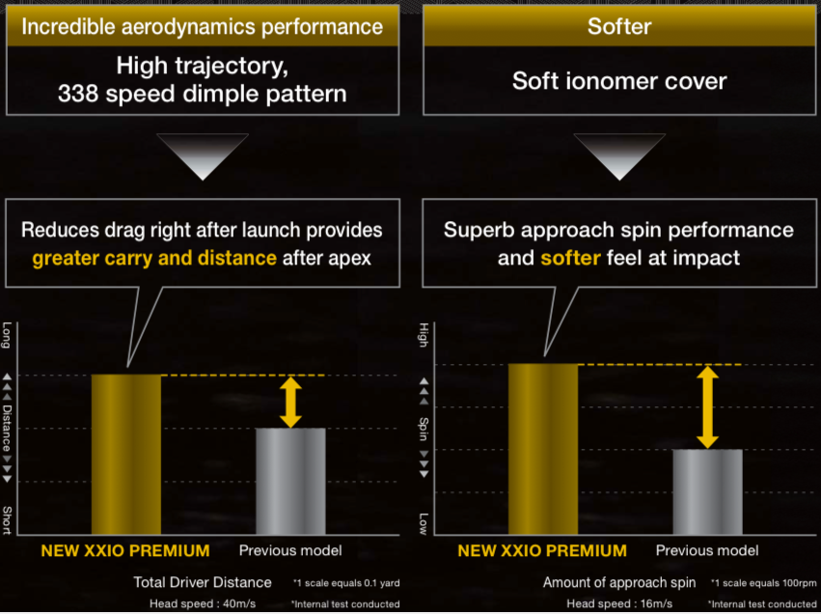

Specifications

Product name |  | XXIO PREMIUM ROYAL GOLF 2018
Construction |  | High-resilience, super soft 3-piece
 | Cover | TEFABLOC® HR+ blended, high-resilience soft ionomer cover
 | Mid-layer | High-resilience, super soft mid-layer
 | Core | High-resilience, large diameter soft E.G.G.* core
 | Dimple | High trajectory 338 speed dimples
Color |  | white
Ball numbers |  | 1, 2, 3, 4, 5, 6, 7, 8
RRP |  | 59,99 €, 69,99 CHF
Release date: |  | March 2018

