New Srixon Z 65 Series

**Product Name:** New Srixon Z 65 Series Woods and Irons

**Product Intro Date:** 25th July 2016

**Product At Retail Date:** 16.09.2016

**Product Head-liner**: Maximum Distance and Control

**Product Introduction:**

INTRODUCING Z65.

DESIGNED FOR MAXIMUM DISTANCE AND CONTROL, THESE ARE THE MOST INNOVATIVE, HIGHEST PERFORMING CLUBS SRIXON HAS EVER MADE.

**Features & Benefits**

Srixon Z 65 Series Drivers

Thanks to continual design innovations, delivered by Srixon’s expert R&D and engineering teams, the two new drivers in the Z 65 series - the Z 565 and Z 765 feature an array of technologies that deliver higher launch, more forgiveness and increased distance.

The Z 565 features a new 460 CC head that optimises and promotes a higher launch, generates more forgiveness and is also equipped with a slight draw bias. With its rounded footprint head and shallow face design, the Z 565 enhances easy playability, inspires more confidence at address and is suitable for a wide range of player abilities. A 10% higher COR area also generates higher ball speeds across the entire face for more distance stability and less dispersion on off-centre hits.

The Z 765 driver is slightly smaller in design and suited to the better player. ***Only available as a custom option.***

Both drivers are also the beneficiaries of a never before seen technology called ‘The Ripple Effect’. This cutting-edge design encompasses three ingenious design features that come together to generate performance like never seen before.

A Power Wave Sole absorbs more stress at impact for maximum energy transfer that results in higher ball speed and increased distance. The new Stretch Flex Cup Face has been extended farther around the crown and sole to create an incredible 10% larger sweet spot area. Lastly a new Lightweight Crown has allowed for four grams of discretional weight to be repositioned for higher launch and increased club head MOI.

The superior innovation and premium quality of the all-new Srixon Z 765 driver has already been validated at the highest level prior to its official launch. China’s Ashun Wu won the Lyoness Open on the European Tour, and Yosuke Tsukada recorded his first professional victory at the JGTO Japan Golf Tour Championship. So there’s already been a ripple effect on tour with the Z 65 series driver.

Loft Options: 9.5 & 10.5

Srixon Z F65 Series Fairway Woods

The all-new Srixon Z 65 fairway woods have also benefitted from some similar alterations to the previous model. Like the new driver, the Z F65 fairway woods feature Ripple Effect technology, delivering the most advanced innovation and best performance Srixon has ever manufactured.

Designed for maximum distance with a higher, more forgiving launch, the Z F65 comes into its own thanks to the three Ripple Effect innovations that work together to maximise distance and control off the tee and fairway.

The new Power Wave Sole absorbs more stress at impact for maximum energy transfer, generating higher ball speed and distance. A Stretch Flex Cup face has been extended farther around crown and sole to create a 10% larger sweet spot. Lastly a new Lightweight Crown features a thinner structure that allows four grams of weight to be repositioned for higher launch and club head MOI.

The Z F65 also features an Arc Support Channel which is progressively deeper by loft to stabilise initial launch conditions for more consistent distance and accuracy from longer distances.

Available Models: 3+, 3, 4 & 5 woods

Srixon Z H65 Hybrids

The Srixon Z H65 hybrid is creating a Ripple Effect, delivering the most advanced innovation and best performance Srixon has ever made. Designed for maximum distance with a higher, more forgiving launch, these impressive looking clubs feature a new Arc Support Channel that is progressively deeper by loft to stabilise initial launch conditions for more consistent distance and accuracy from longer distances.

The Z H65 hybrids also feature optimised Center of Gravity locations, meaning lower lofts (2, 3, and 4) feature a lower center of gravity promoting a higher initial launch.

Srixon Z 565 Irons

The Z 565 irons are geared for golfers of all abilities and feature a new Tour V.T sole that allows the club head to move even more efficiently through the turf, reducing impact resistance and tightening shot dispersion for more overall control. They also feature a high strength SUP10 face insert for higher ball speed and more distance. Compared to the previous model, 5% larger grooves feature in the Z 565 irons as well as Double Laser Milling for better contact, especially in wet conditions.

Srixon Z 765 Irons

The Srixon Z 765 irons have made Srixon’s best iron performance even better. The Z 765 is a muscle cavity preferred by skilled players for its traditional profile and exceptional control.

The new Tour V.T. Sole has been modified to move even more efficiently through the turf, reducing impact resistance and tightening shot dispersion for maximum consistency and control.

Ultra-soft S20C head material with a new special heat treatment ensures the new Z 765 irons are precision forged for the smoothest, most consistent feel. All iron faces feature 5% larger grooves compared to the previous generation and Double Laser Milling. This improves contact, especially in wet conditions, for increased friction and enhanced spin control.

Srixon Z 965 Irons

The Z 965 is a compact muscle back blade ideal for the most advanced, demanding players. A new Tour V.T. Sole has been modified to move even more efficiently through the turf, reducing impact resistance and tightening shot dispersion for maximum consistency and control. The feeling off these precision forged irons is unsurpassed, combining ultra-soft S20C head material with a new special heat treatment for the smoothest and most consistent feel.

All iron faces feature 5% larger grooves compared to the previous generation and Double Laser Milling, which improves contact, especially in wet conditions, delivering increased friction and enhanced spin control.

Srixon ZU65 Utility Irons

The brand-new Z U65 utility iron features a hollow construction in a slim profile. Srixon has managed to achieve unsurpassed feel with unmatched distance with a new S20C body and SUP10 face. Like the new Z 65 irons, these utility clubs also feature 5% larger grooves for more spin and control on longer shots into greens. The Z U65s hollow construction also allows weight in the club head to be repositioned low in the head for a higher initial launch resulting in further overall carry.

The Z U65 utility features the same ‘Ripple effect’ that can be found in the Z 65 series driver and fairway wood. It’s the most advanced innovation that Srixon has ever made and offers maximum distance and a more forgiving launch.

Specifications:

Driver: 565 765 only available as a custom option



Fairway Z F65



Hybrid Z H65



Ultility Z U65



Irons Z 565

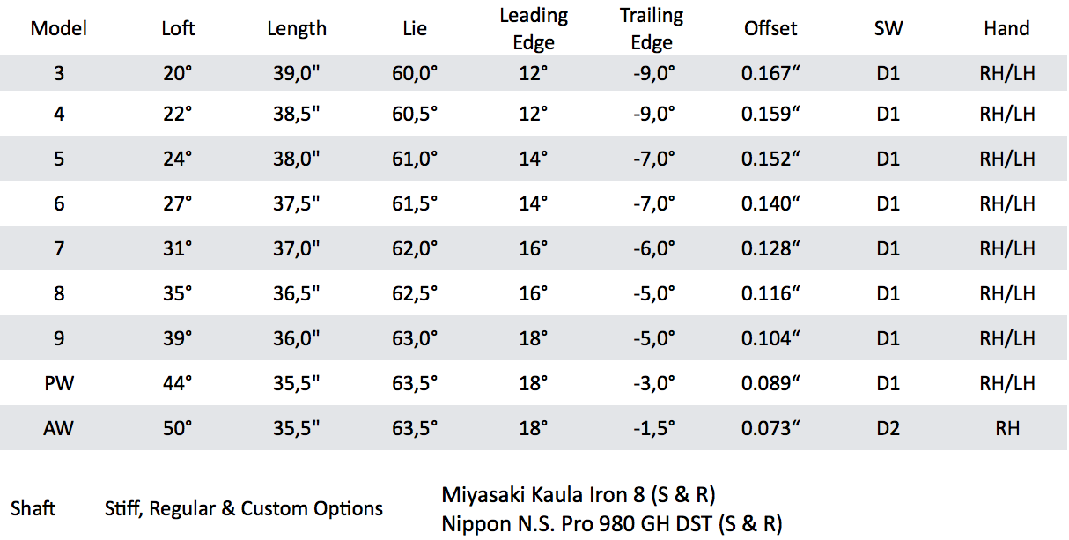

Irons Z 765

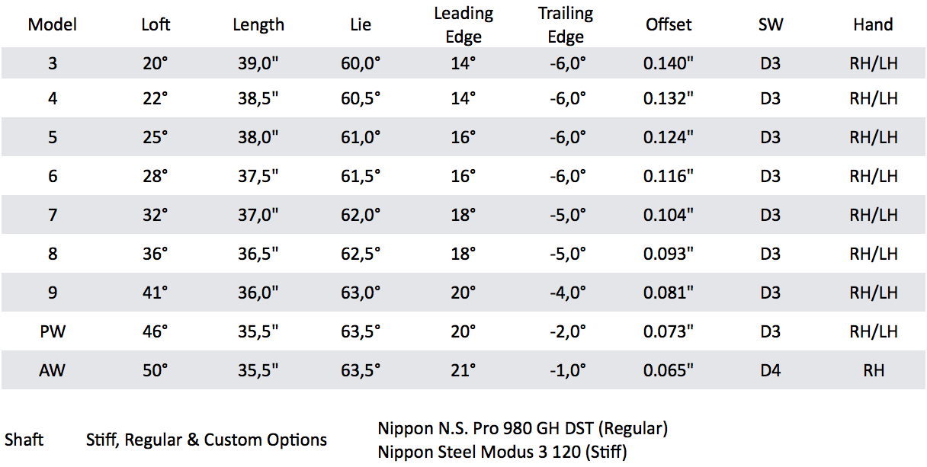

Irons Z 965

