NEW Product - introduction

Product Name: New 2018 Z Series

Product One- Liner: Woods Crafted for Tour Performance

EMBARGO UNTIL 27th August / LAUNCH 14TH SEPTEMBER

Product Intro:

The new Z Series woods present a revolution in woods performance, delivering the most powerful suite of offerings from Srixon. The full line of Z Series woods features advanced materials to help amplify your long game.

Feature and Benefits

“The new Z Series woods are pretty easy to explain: they’re long,” said Marketing Director Brian Schielke. “Longer than our past woods, and longer than the competition. Our stronger, faster titanium, combined with cup face construction is totally unique, totally different from everything out there, and it really shows up both on a launch monitor and on the course.”
The Z Series driver will boost your speed and distance off the tee with the Ti51AF Cup Face. This cup face is the thinnest, lightest, strongest, and hottest driver face Srixon has ever produced.
“This driver’s faster. This driver’s longer. This driver’s better,” said Keegan Bradley. “It’s really coming off hot and straight. It’s very forgiving and the sweet spot is really big.”
Featuring a lightweight carbon crown, Z Series woods shift the weight to the perimeter, offering more forgiveness and less offline dispersion.
The Z 785 driver promotes a low-spin, penetrating trajectory in a tour preferred look and profile.
The same powerful technologies that deliver more speed, distance and forgiveness are present in the Z F85 fairway woods and Z H85 hybrids.

Key Innovations Inside Z Series woods:

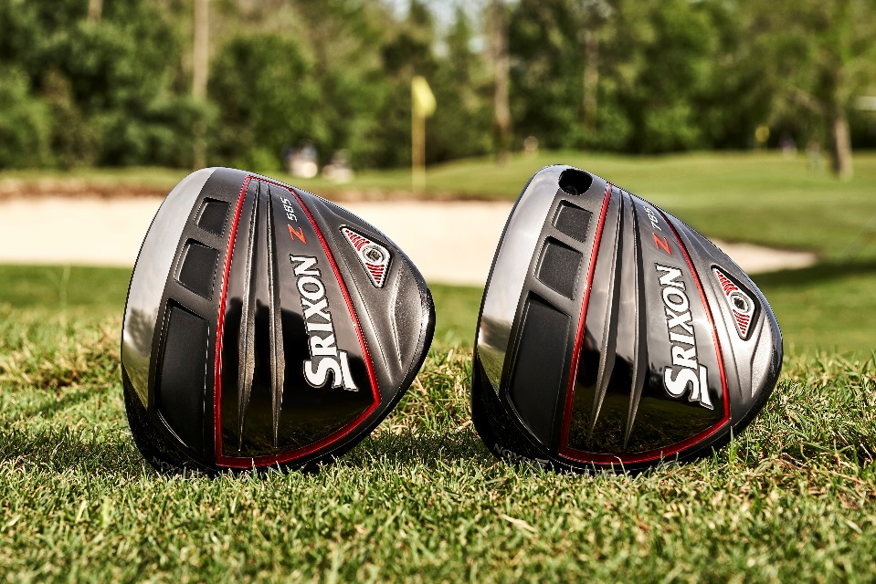
- Ti51AF Cup Face – Stronger, lighter and faster. The new Ti51AF Cup Face produces exceptional ball speed for greater distance.
- Lightweight Carbon Crown – The lightweight carbon crown moves mass to the perimeter for more forgiving and accurate drives.
- Quick Tune System – Available in both Z Series driver, effortlessly adjust loft and swing weight with the Quick Tune System.
- Premium Shafts – Miyazaki Mahana Shafts don’t just feel faster, they are faster. With reduced stiffness in their mid-section, these premium shafts create a controlled yet flexible feel while boosting your speed and total distance.
The top-performing tour shaft Handcrafted Project X HZRDUS shaft is also available in custom.
“A big key for me is accuracy,” said Graeme McDowell. “I love the bulge and roll look to this head, and I really feel like I can hit a lot of fairways with it. It’s just a beautiful looking driver that’s got a nice high launch and looks like the ball wants to topple over and get max distance.”

DRIVER Z785 :
RRP in EUR | 399,99
RRP in CHF | 449,99
RRP in SEK | 4199,99

FW Z85 :
RRP in EUR | 229,99
RRP in CHF | 249,99
RRP in SEK | 2399,99

Z85
HB HY:
RRP in EUR | 199,99
RRP in CHF | 219,99
RRP in SEK | 1999,99

