Srixon Sports Europe Ltd
Centre Erlia, ZI du Jalday
64500 ST JEAN DE LUZ
(E-MAIL) isabelle.hascoet@srixoneurope.com

FOR IMMEDIATE RELEASE

Srixon Introduces The New Soft Feel Golf Ball:
Softness never brought you this far

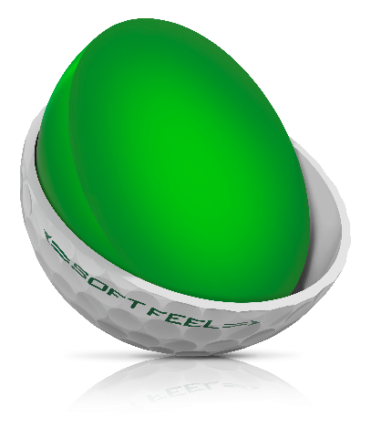
SAINT JEAN DE LUZ — August 1, 2018 — SRIXON®, a global leader in golf ball technology and innovation, announces the launch of the new Soft Feel golf ball. The Srixon Soft Feel is available in Soft White™ and Tour Yellow™ and officially launches in Europe on August 15, 2018.

Now in its 11th generation, Srixon engineered the latest iteration of the Soft Feel specifically for golfers wanting to maximize distance and control with exceptional feel. Featuring a soft cover, innovative core, and upgraded dimple pattern, the Soft Feel delivers all-around performance from tee to green at an unmatched price. Longer. Softer. Better. The new Soft Feel from Srixon.

“The all-new Soft Feel was designed to help players maximize their distance off the tee, while providing even better feel and control,” said Jeff Brunski, Vice President of Research and Development. “The latest generation of Soft Feel accomplishes this goal offering a lower compression ball for incredible distance, but a softer cover to provide that greenside performance all players crave. The Soft Feel provides all-around performance at an incredible value which really separates this golf ball from the rest.”

The key technologies inside the new Soft Feel include:
- Energetic Gradient Growth Core. Soft Feel’s core technology provides a high-launch, low spin trajectory off the tee for added distance with an ultra-soft feel.
- Soft, Thin Cover. The softer, thinner cover promotes more greenside spin and a softer feel on all pitches, chips and putts.
- 338 Speed Dimple Pattern. The upgraded dimple pattern reduces drag and cuts through the wind for more accuracy and consistency on every shot.

Srixon Sports Europe Ltd
Centre Erlia, ZI du Jalday
64500 ST JEAN DE LUZ
(E-MAIL) isabelle.hascoet@srixoneurope.com
FOR IMMEDIATE RELEASE

Independent Test Results:

Srixon worked with Golf Laboratories, Inc. to conduct independent, outdoor robot testing of the new Soft Feel golf ball against key competitors. The results show how Soft Feel provides optimal tee-to-green performance at an incredible value:

- The Energetic Gradient Growth Core and new 338 Speed Dimple Pattern provide ideal launch conditions and less drag, which delivers longer driver distance than more expensive ionomer cover competitors.
- The Soft Feel stands apart in terms of accurate iron play. The core technology, along with the new aerodynamic dimple pattern, allows the new Soft Feel to cut through any conditions, offering more distance, consistency and control with your irons.
- Srixon’s Soft Feel completes its all-around performance, and separates from the competition, with better greenside spin and control. Thanks to the thinner, softer cover, the Soft Feel generates more spin on pitch, chips shots than its more expensive competitors.

The Srixon Soft Feel golf ball officially launches in Europe on August 15, 2018, at a MAP of 24,99€ per dozen.

ABOUT Srixon®:
Based in Huntington Beach, CA, Srixon®, is part of the Sumitomo Rubber Industries, Ltd. family and enjoys a strong presence on competitive tours worldwide. The professional staff includes players such as Hideki Matsuyama, Graeme McDowell, Keegan Bradley, Inbee Park, as well as many others. Srixon®, with more than 80 years of golf ball manufacturing experience, is committed to providing "Tour-proven, premium golf equipment to passionate golfers seeking to improve their performance while enhancing their experience playing the game of golf.” For more information, please contact Noelle Zavaleta at (714) 889-5853 or visit srixon.com.

