Media Embargo: January 21st, 2019

SRIXON INTRODUCES THE ALL-NEW Z-STAR SERIES:
BUILT FOR DISTANCE
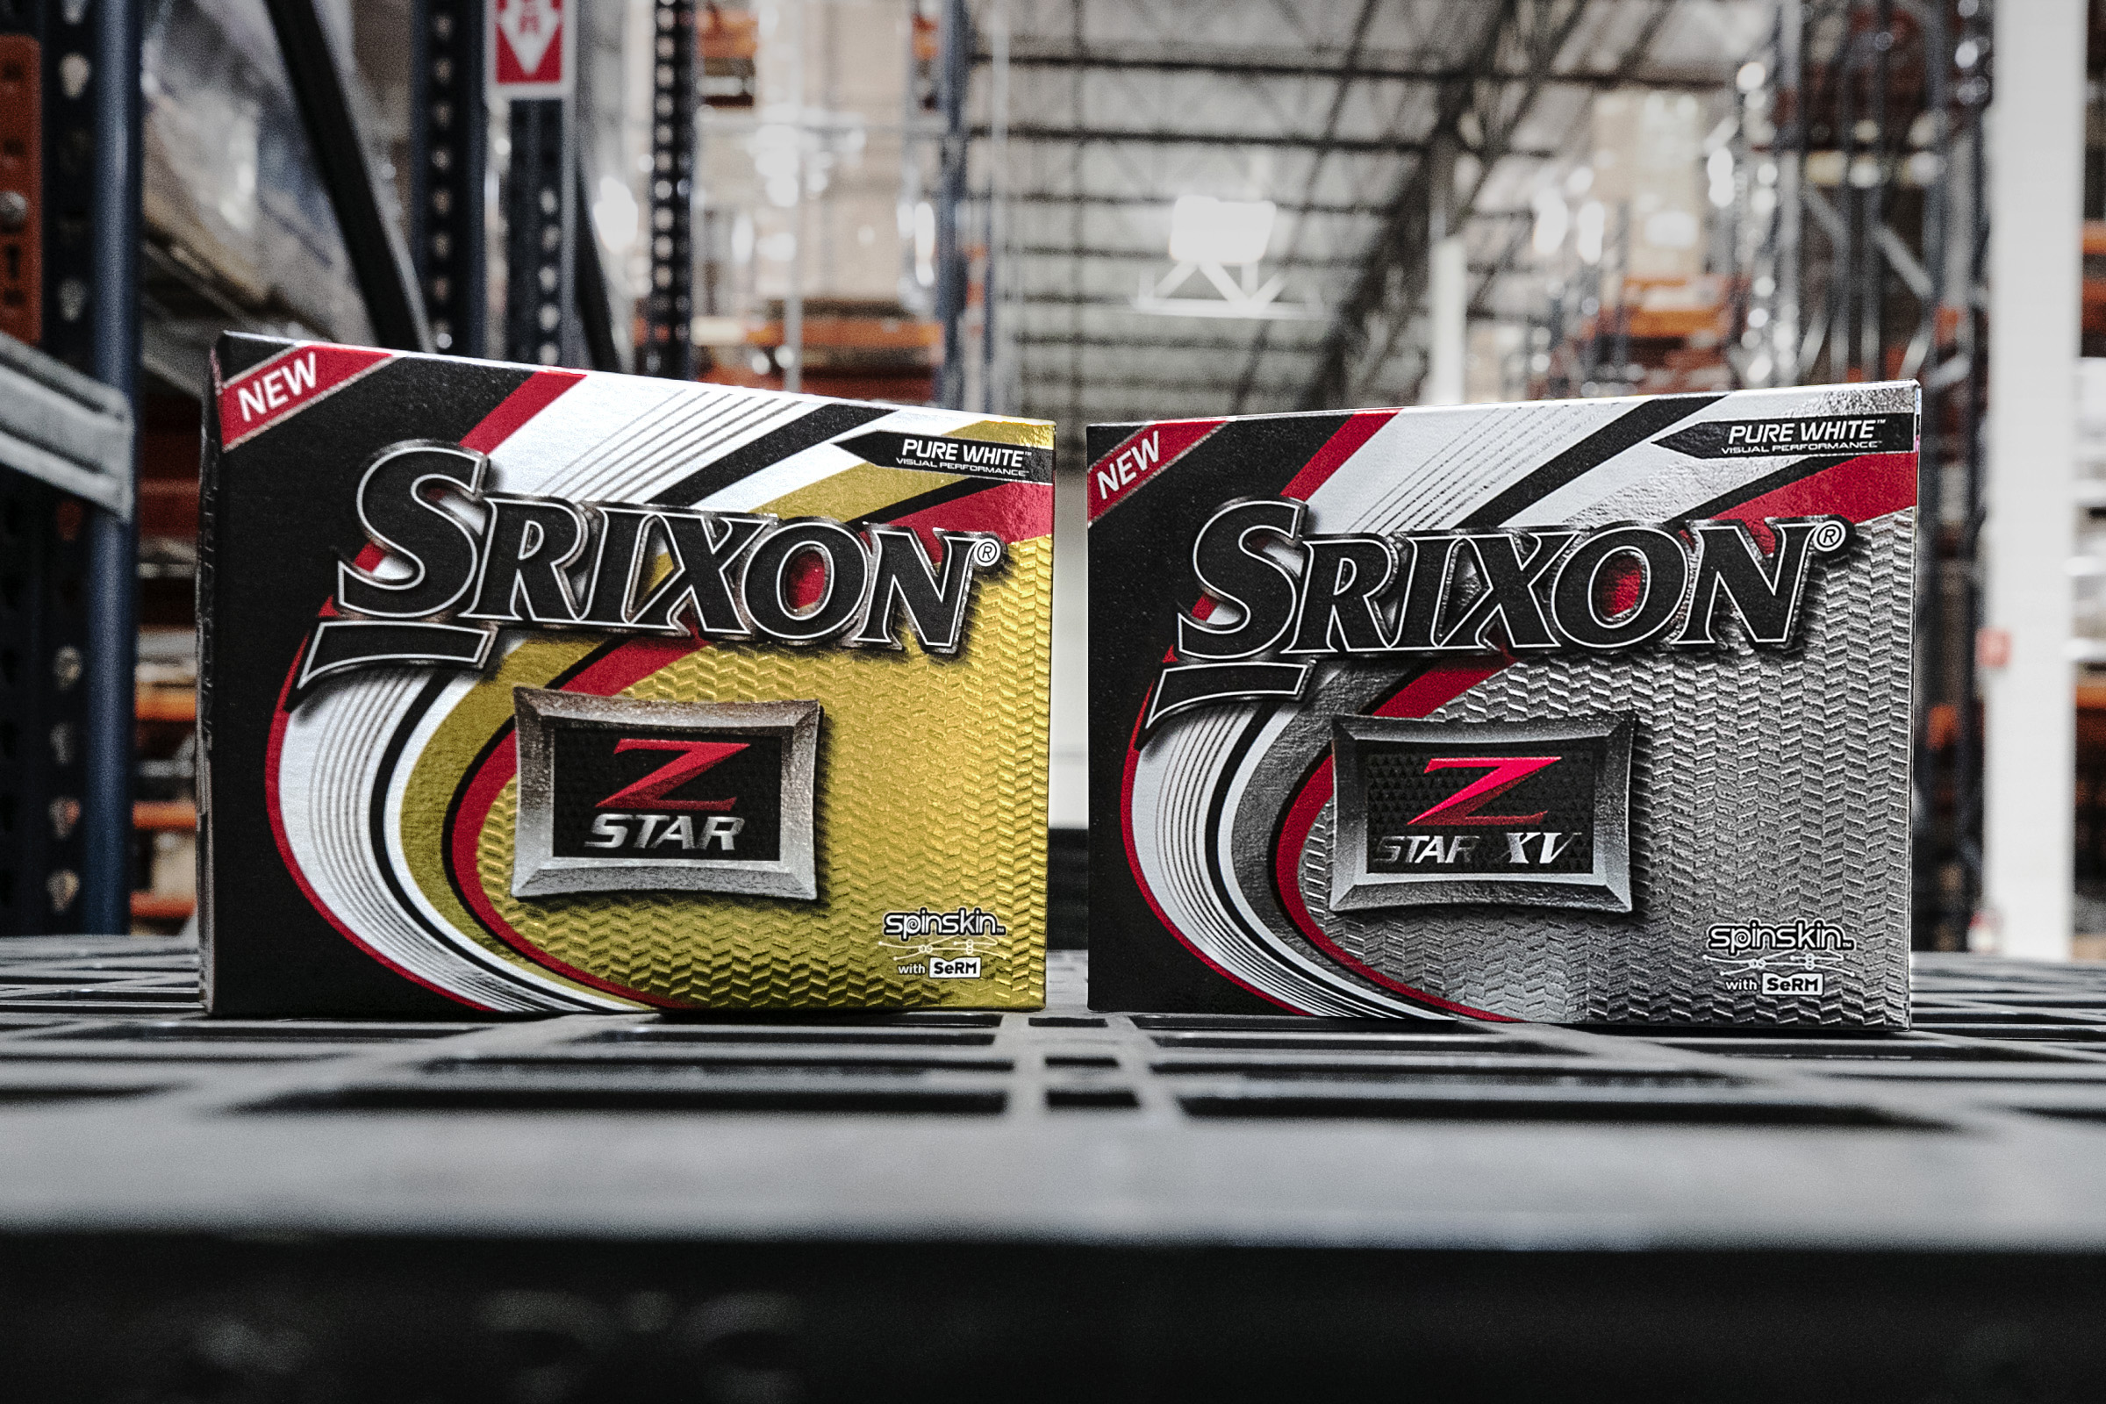

SRIXON SPORTS EUROPE, January 21st, 2019: SRIXON®, a global leader in golf ball technology and innovation, announces the launch of the sixth generation Z-STAR Series golf ball. The Srixon Z-STAR XV and Z-STAR are available in Pure White™ and Tour Yellow™ and officially launch across Continental Europe on March 1, 2019.

“Distance is one of the major strengths of my game, and I trust the performance of the Z-STAR XV like nothing else on Tour,” said professional Cameron Champ, who currently leads the Tour in driving distance. “The exceptional ball speed and distance that I’m able to generate with the Z-STAR Series gives me the unique opportunity to compete at an elite level week-in-and-week-out.”

The sixth generation Z-STAR Series features the totally new FastLayer Core, a revolutionary way to make a golf ball core. It starts soft in the center and gradually becomes firmer around its edge. This greatly enhances ball speed for maximum distance performance, while maintaining exceptional feel at impact.

“The new Z-STAR Series golf balls are built on top of the heritage of one of the most successful, trusted Tour golf balls in the market,” said Jeff Brunski, Vice President of Research and Development. “The exceptional ball speed and distance of both Z-STAR offerings are driven by the new FastLayer Core technology, producing both outstanding ball speed and launch conditions tuned for the high swing-speed, better player.”

The new Z-STAR Series golf balls feature new Spin Skin technology with Slide-Ring Material (SeRM), a urethane compound that coats the cover of every Z-STAR Series golf ball. By taking unprecedented levels of shearing force without breaking its molecular bonds, Spin Skin with SeRM is able to dig deep into your wedge and iron grooves, dramatically increasing friction and maximizing spin for more control and more stopping power on every shot.

The all-new Z-STAR Series golf balls are the first and only in the world to use Slide-Ring Material, providing a competitive advantage that cannot be matched.

“Engineered for more spin and control, the Z-STAR Series features a Spin Skin coating enhanced with SeRM, an extremely flexible material,” Brunski said. “Never before has Srixon combined so many technologies in one golf ball, to produce more friction for more spin around the green.”

The 338 Speed Dimple Pattern on each Z-STAR Series golf ball improves overall aerodynamics for better flight performance, even in the toughest wind conditions, with drivers, woods and irons.

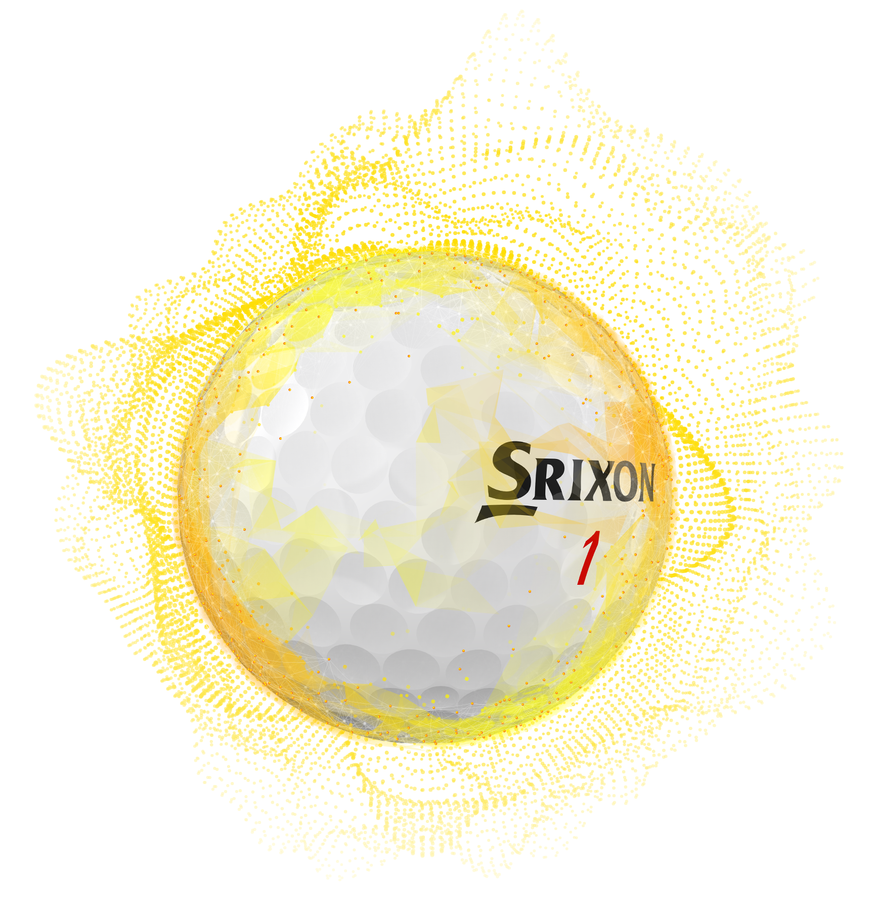
The sixth generation Z-STAR XV features a softer urethane cover and Spin Skin with SeRM, which significantly increases greenside spin for more short game control. It features a four-piece construction with a smaller inner core and larger outer core for more distance off the tee.

“The new Z-STAR XV is hotter off the driver,” said four-time Tour winner Keegan Bradley. “It’s definitely longer with my irons as well. So, it’s a ball that’s going to help you throughout the entire bag.”

Similarly, the new Z-STAR golf ball features Spin Skin with SeRM, which increases greenside spin and short game control, while maintaining that soft feel. In addition, the 2019 Z-STAR employs a three-piece construction and slightly increased compression with a harder mantle layer for more ball speed, reduced spin and more distance.

KEY TECHNOLOGIES:

- NEW FASTLAYER CORE: The FastLayer Core starts soft in the center and gradually becomes firm around its edge, giving high-speed players exceptional feel and enhanced ball speed for maximum distance.
- 4TH GENERATION SPIN SKIN WITH SeRM: A new coating with flexible molecular bonds digs deep into wedge and iron grooves, maximizing spin for more control and more stopping power.
- 338 SPEED DIMPLE PATTERN: The 338 Speed Dimple Pattern offers less drag and more lift to boost overall distance, while flying straight even in the toughest wind conditions.

Click here for product images, test results from the Z-STAR Series Product Manual and to learn more about the latest offerings from Srixon.

The Srixon Z-STAR Series golf balls officially launch across Continental Europe on March 1st, 2019, at an SRP of €50 / CHF 55 / SEK 500 per dozen.

Visit www.srixoneurope.com for more information on the new Z-STAR and all Srixon products

Further information, images and media requests are available from James Lovett at Front 9 Group.
Email: james@front9group.com
Tel: +44 (0) 7885599932

ABOUT Srixon®:
Based in Huntington Beach, CA, Srixon®, is part of the Sumitomo Rubber Industries, Ltd. family and enjoys a strong presence on competitive tours worldwide. The professional staff includes players such as Hideki Matsuyama, Graeme McDowell, Keegan Bradley, Inbee Park, as well as many others. Srixon®, with more than 80 years of golf ball manufacturing experience, is committed to providing "Tour-proven, premium golf equipment to passionate golfers seeking to improve their performance while enhancing their experience playing the game of golf.”

Follow Srixon Europe on social media at:
Twitter: https://twitter.com/SrixonEurope
Facebook: https://www.facebook.com/SrixonEurope
Instagram: https://www.instagram.com/srixoneurope/

