Embargo: March 1st, 2019

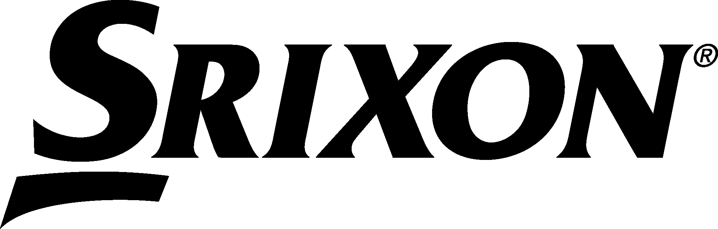
SRIXON UNVEILS Z-FORGED:
NEXT GENERATION TOUR PERFORMANCE

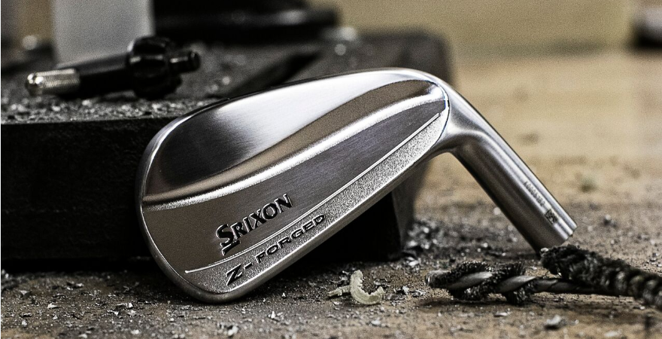

SRIXON SPORTS EUROPE, March 1st, 2019: SRIXON®, a global leader in in golf equipment and innovation, introduces Z-FORGED, a muscle back blade iron crafted for the best players in the world. Srixon’s Z-FORGED officially launches in Continental Europe on March 1st, 2019.

Z-FORGED begins with two sharp lines at the back, one from the toe and one from the heel, which form its signature double curve design. Z-FORGED elevates iron performance with its forged construction delivering an unrivaled soft feel in a crisp, explosive profile. Designed for the ultimate ball-strikers yet engineered to perform, Z-FORGED is the ultimate blade iron, realized.

“The new Z-FORGED irons are the most compact, most workable irons in our line,” said Dustin Brekke, Engineering Manager. “They were created to give professionals and advanced amateur golfers confidence to hit every shot, while featuring a sole that glides through the turf for better contact and stable spin under any condition.”

Key Technologies:

- Muscle Back Blade: Classic blade shaping optimized for maximum workability and unmatched feel.
- Updated Tour V.T. Sole: A newly redesigned Tour V.T. Sole provides more consistent ball striking while maintaining enough versatility to execute any shot.
- Forged Construction: Forged from a single billet of soft 1020 carbon steel for exceptional feel.

The Srixon Z-FORGED officially launch in Continental Europe on March 1st, 2019 with the following suggested retail prices:

Single Iron: €149, CHF 164,99, SEK 1,399
Six Club set: €899,99, CHF 989,99, SEK 8,399

CLICK HERE for additional product information and images on the new Z-FORGED and to learn more about the latest offerings from Srixon.

Visit www.srixoneurope.com for more information on the new Z-FORGED and all Srixon products

Follow Srixon Europe on social media at:
Twitter: https://twitter.com/SrixonEurope
Facebook: https://www.facebook.com/SrixonEurope
Instagram: https://www.instagram.com/srixoneurope/

Further information, images and media requests are available from James Lovett at Front 9 Group.
Email: james@front9group.com
Tel: +44 (0) 7885599932

ABOUT Srixon®:
Based in Huntington Beach, CA, Srixon®, is part of the Sumitomo Rubber Industries, Ltd. family and enjoys a strong presence on competitive tours worldwide. The professional staff includes players such as Hideki Matsuyama, Graeme McDowell, Keegan Bradley, Inbee Park, as well as many others. Srixon®, with more than 80 years of golf ball manufacturing experience, is committed to providing "Tour-proven, premium golf equipment to passionate golfers seeking to improve their performance while enhancing their experience playing the game of golf.”

