FOR IMMEDIATE RELEASE

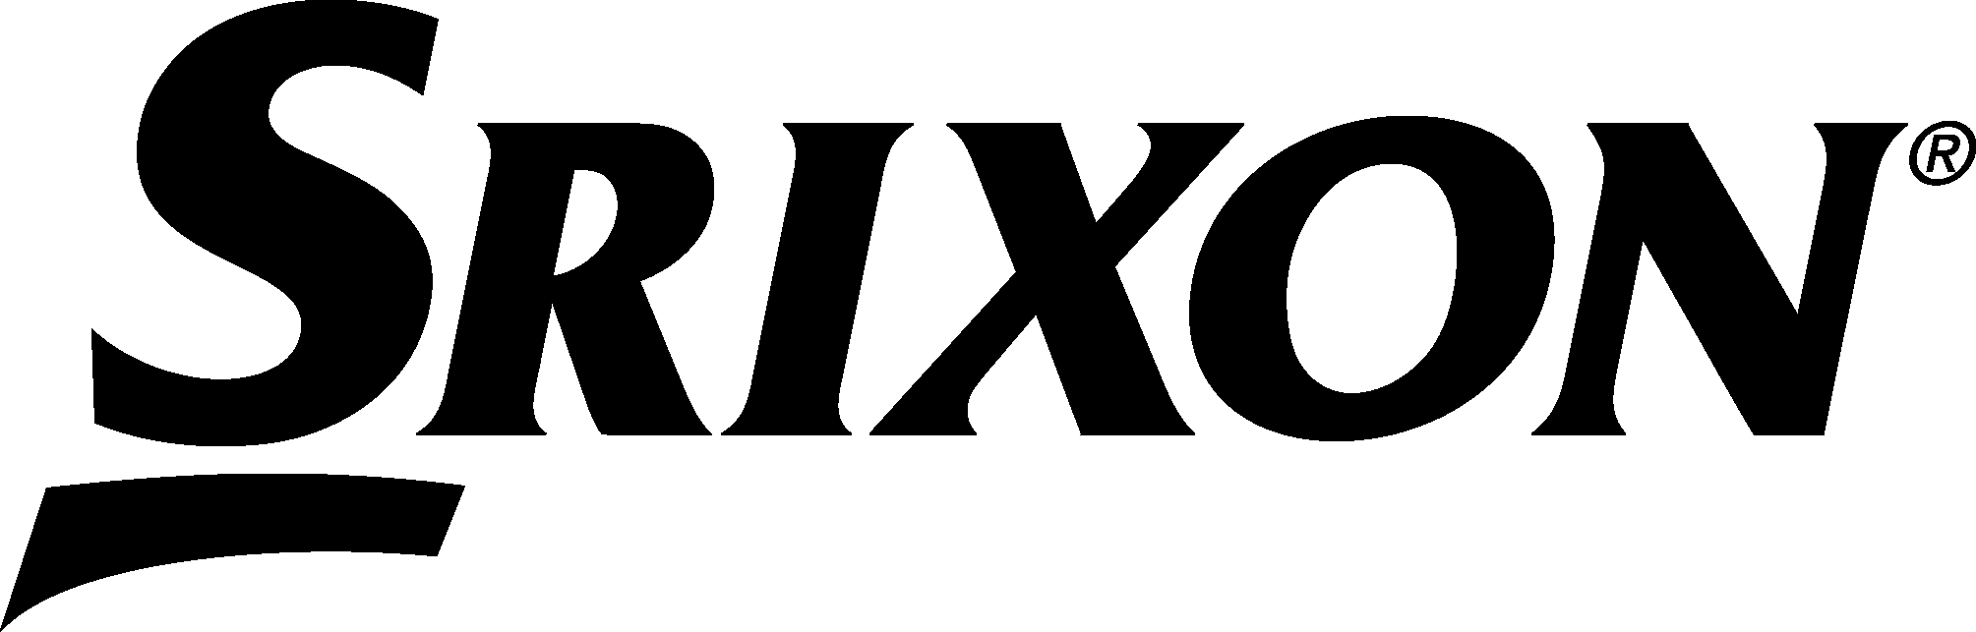
SRIXON UNVEILS THE NINTH GENERATION AD333 GOLF BALLS

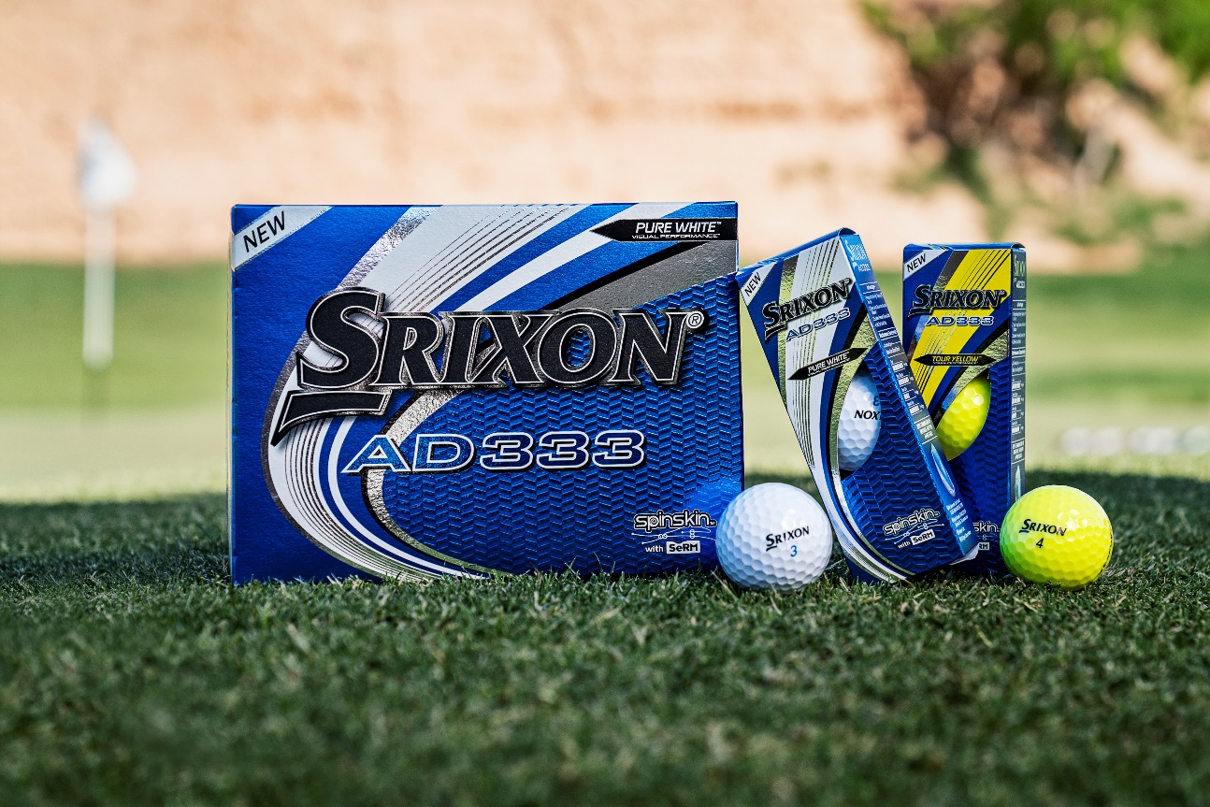

Saint jean de luz, France — 15th July 2019 — SRIXON®, a global leader in golf ball technology and innovation, announces the launch of the ninth generation AD333 golf ball. The Srixon AD333 is available in Pure White™ and Tour Yellow™ and officially launches in Continental Europe on 15th August 2019.

“The new AD333 maintains and builds on the high-quality performance that consumers throughout Europe have come to expect from our leading two-piece golf ball,” said Lionel Caron, President Continental Europe. “Featuring a number of new technologies, including a new FastLayer Core, our designers have done an amazing job to deliver a 9th generation AD333 that promises even more ball speed and distance.”

The all-new FastLayer Core starts soft in the center and gradually becomes firmer around its outer edge. By incorporating this technology in the all-new AD333, FastLayer helps generate maximum distance, without sacrificing that exceptional feel at impact. FastLayer works in tandem with AD333’s 338 Speed Dimple Pattern, which reduces drag for a more penetrating ball flight, to help deliver more distance off the tee regardless of the playing conditions.

Furthermore, the new AD333 golf balls feature Srixon’s proprietary Spin Skin technology with Slide-Ring Material (SeRM), a urethane compound that coats the cover of every AD333 golf ball.

Spin Skin with SeRM digs deep into wedge and iron grooves, dramatically increasing friction at impact and maximizing spin for more stopping power on every shot.

“With the addition of the new FastLayer Core and Spin Skin with SeRM, the latest generation of AD333 golf balls deliver superior, all-around performance compared against similar offerings in the market,” said Lionel Caron.

Key Technologies:

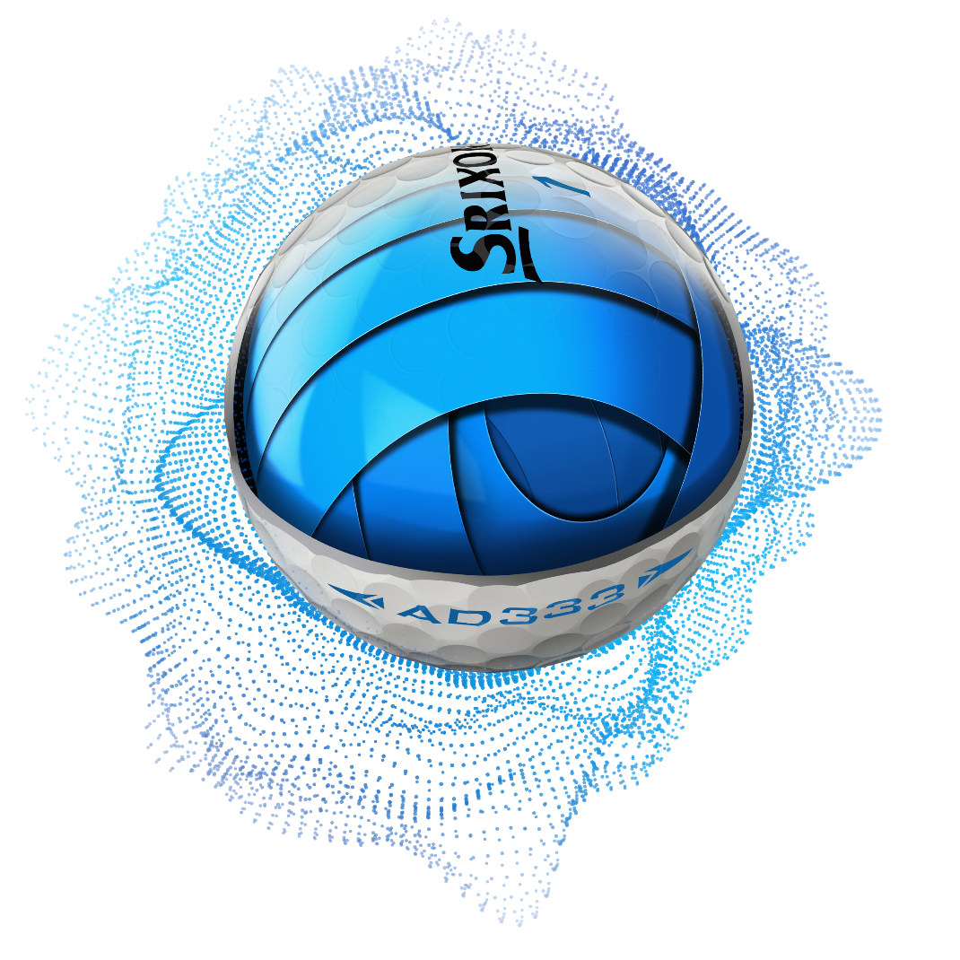

New FastLayer Core: Starting soft in the center and gradually becoming firm around its outer edge, FastLayer delivers exceptional feel and ball speed for maximum distance
performance.

New Spin Skin with SeRM: SeRM, a new urethane coating with flexible molecular bonds, digs deep into wedge and iron grooves for more control and more stopping power.

338 Speed Dimple Pattern: The 338 Speed Dimple Pattern provides less drag and more lift to boost overall distance, while flying straight even in the toughest wind conditions.

Click HERE for more images, test results from the AD333 Series Product Manual, and to learn more about the latest offerings from Srixon.

The Srixon AD333 golf balls officially launch in Continental Europe on 15th August, 2019 at a MAP of 30€ / 33 CHF / 300 SEK per dozen.

Visit www.srixoneurope.com for more information on all Srixon products

Follow Srixon Europe on social media at:
Twitter: https://twitter.com/SrixonEurope
Facebook: https://www.facebook.com/SrixonEurope
Instagram: https://www.instagram.com/srixoneurope/

Further information, images and media requests are available from James Lovett at Front 9 Group. Email: james@front9group.com / Tel: +44 (0) 7885599932

ABOUT Srixon®:
Based in Huntington Beach, CA, Srixon®, is part of the Sumitomo Rubber Industries, Ltd. family and enjoys a strong presence on competitive tours worldwide. The professional staff includes players such as Hideki Matsuyama, Graeme McDowell, Keegan Bradley, Inbee Park, as well as many others. Srixon®, with more than 80 years of golf ball manufacturing experience, is committed to providing "Tour-proven, premium golf equipment to passionate golfers seeking to improve their performance while enhancing their experience playing the game of golf.”

