CLEVELAND GOLF INTRODUCES LAUNCHER HB TURBO WOODS:
GO FASTER
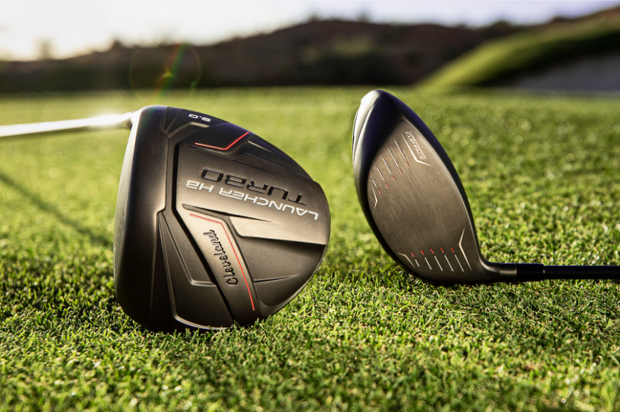
SAINT JEAN DE LUZ, France – Sept. 16, 2019 – Cleveland® Golf, where scoring matters, is proud to announce the Launcher HB Turbo Driver and Launcher HB Turbo Fairway Woods. The Launcher HB Turbo launches Continental Europe on October 16, 2019.

“Reintroducing Cleveland Golf Woods and Irons two years ago has been very successful said Lionel Caron, President Continental Europe. “However, the new Launcher HB Turbo woods represent a huge step up from the previous generation. They’re sleeker, faster, and more forgiving – exactly what all of us avid golfers are looking for off the tee.”

For Cleveland Golf, Launcher has always stood for one thing: launching the ball high in the air and straight down the fairway. The new Launcher HB Turbo remains committed to that mission with a lighter hosel, improved crown, and deeper weighting. Only now, it’s faster.

“The Launcher HB Turbo is engineered to help you hit long, straight drives,” said Jeff Brunski, Vice President of Research and Development at Cleveland Golf. “We’ve squeezed discretionary weight out of every corner of the club head in order to produce one of the most forgiving drivers we’ve ever made. We’ve paired it with a high-balance point shaft that’s easier to swing fast. Authentic technologies such as the Turbocharged Cup Face, the Ultralight Hosel, and a more aerodynamic crown help the Launcher HB Turbo earn its name.”

The Launcher HB Turbo features a Turbocharged Cup Face, which offers a unique variable thickness pattern that delivers more speed across the entire face. The Turbocharged Cup Face stretches along the crown and sole, flexing at impact and reflecting that energy back into the ball for increased ball speeds at impact.

The redesigned HiBore Crown features a prominent step that lowers the center of gravity, while the Ultralight Hosel is even lighter to remove mass from a poor position. All of these weight savings culminate in the Deep Weighting sole pad. The result: a center of gravity that’s 4.4mm deeper and 2.2 mm lower, increasing launch at impact and maximizing distance off the tee.

Launcher HB Turbo comes standard with the new Miyazaki C. Kua shaft, which pulls weight from the length of the shaft and repositions it on the grip end. This makes the shaft feel incredibly easy to swing and allows for extra mass in the club head for increased momentum and more speed on every swing.

The same speed-enhancing technologies that define the Launcher HB Turbo Driver are featured within the Launcher HB Turbo Fairway Woods, delivering more speed and distance off the tee or when going for the green in two.
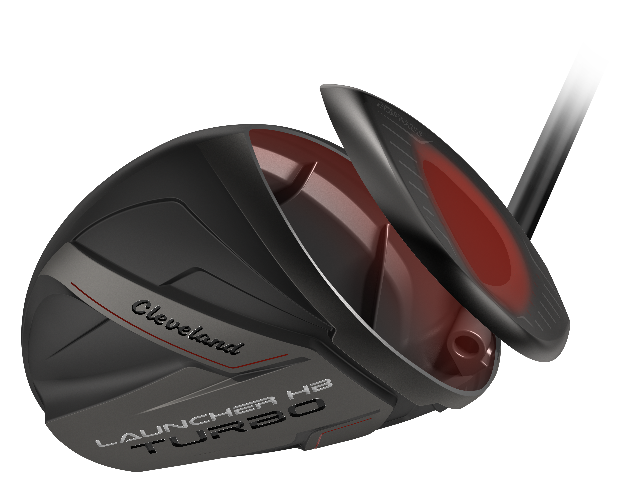
Key Innovations Inside Launcher HB Turbo:

- Turbocharged Cup Face: The new Turbocharged Cup Face, enhanced with a new variable face design, provides higher COR over a larger impact area for increased ball speeds and more distance.
- HiBore Crown: The redesigned HiBore Crown lowers the center-of-gravity (CG) by 2.2mm, enabling a lower CG position for optimal launch conditions.
- Deep Weighting: Discretionary mass savings positioned for significant increases to MOI, delivering more forgiveness.
- Ultralight Hosel: External and internal
weight reduction, redistributed low and deep for a higher launch and more forgiveness.
- Counter Balanced Shaft Design: Specifically designed for the Launcher HB Turbo, the Miyazaki C. Kua’s center-of-gravity is relocated higher toward the grip, enabling additional head mass for increased MOI.

The Launcher HB Turbo Driver is available in two different models: standard (9°, 10.5°, 12° options) and DRAW (10.5°) at a price of €349,00 / CHF 399 / SEK 3490. The Launcher HB Turbo Fairway Woods feature a 3-wood (15°) and 5-wood (18°) at €229,00 / CHF 259 / SEK 2290 each.

For high-resolution images, the Launcher HB Turbo product manual, and other assets CLICK HERE.

For more detailed information on Launcher HB Turbo, please visit: www.clevelandgolf.eu

ABOUT Cleveland® Golf:
Based in Huntington Beach, CA, Cleveland® Golf is part of the Sumitomo Rubber Industries, Ltd. family and enjoys a strong presence on competitive tours worldwide. Their professional staffs include players such as Graeme McDowell, Keegan Bradley, Hideki Matsuyama, Inbee Park, as well as many others. Cleveland® Golf, founded in 1979, is a leading equipment manufacturer specializing in short game technologies and solutions that benefit all golfers. Cleveland® Golf remains steadfastly committed to providing "Tour proven, premium golf equipment to passionate golfers seeking to improve their performance while enhancing their experience playing the game of golf." For more information, please contact Noelle Zavaleta (714.889.5853) or visit us online at www.clevelandgolf.com.

