MEDIA EMBARGO 1ST SEPTEMBER 2019

INJECT COLOUR AND PERFORMANCE INTO YOUR GAME WITH THE ALL-NEW SOFT FEEL BRITE GOLF BALL

A MASTERPIECE IN COLOR
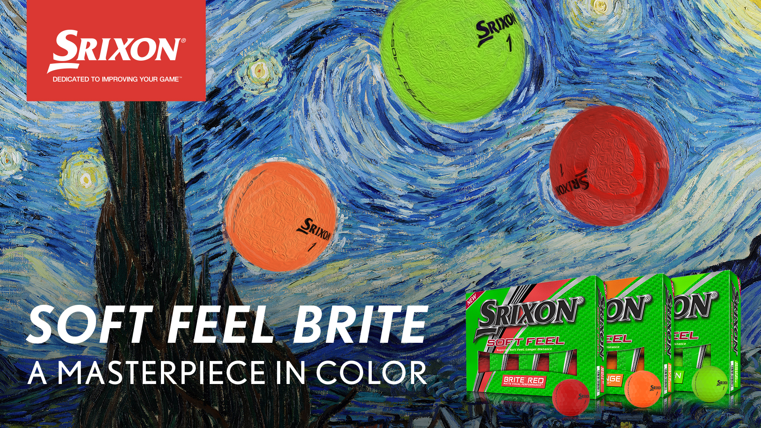
Saint jean de luz, France — 1ST September 2019 — SRIXON®, a global leader in golf ball technology and innovation is delighted to announce the launch of the all-new Soft Feel Brite series, a range of vibrant coloured golf balls featuring a host of advanced technologies, including Matte Visual Performance.
The Srixon Soft Feel Brite is available in Brite Red, Brite Orange and Brite Green and delivers the same soft feel and incredible distance golfers love about the Soft Feel.
The new model officially launches in Continental Europe on 15th September 2019 and comes with a suggested retail price of 25€/28 CHF/250 SEK per dozen.
“The new Soft Feel Brite has been designed to appeal to players looking to inject some colour into their game
whilst still maintaining the high-quality performance that consumers throughout Europe have come to expect from one of our most popular ball categories,” said Lionel Caron, President Continental Europe.

“Featuring a number of new technologies, including Matte Visual Performance, our engineers have done an incredible job to create a ball that makes a statement both in colour and performance.”

Key Technologies in the Soft Feel Brite:

Matte Visual Performance: Enhanced visibility cover, available in three brite colour options.

Energetic Gradient Growth Core: Delivers a high-launch, low spin trajectory off the tee for added distance and an ultra-soft feel.

Soft, Thin Cover: Provides more greenside spin and softer feel on all pitch shots, chips and putts.

338 Speed Dimple Pattern: The lower drag coefficient dimple pattern cuts through the wind for more accuracy and consistency on every shot.

Click HERE for more images, test results from the Soft Feel Brite series Product Manual, and to learn more about the latest offerings from Srixon.

The Srixon Soft Feel Brite golf balls officially launch in Continental Europe on 15th September 2019 at a MAP of 25€/28 CHF/250 SEK per dozen.
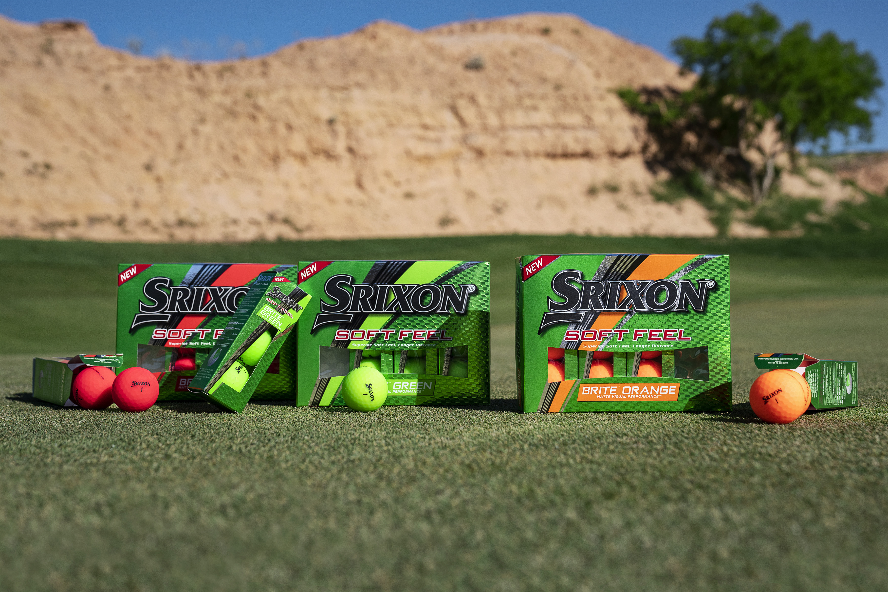
Visit www.srixoneurope.com for more information on all Srixon products

Follow Srixon Europe on social media at:
Twitter: https://twitter.com/SrixonEurope
Facebook: https://www.facebook.com/SrixonEurope
Instagram: https://www.instagram.com/srixoneurope/

Further information, images and media requests are available from James Lovett at Front 9 Group. Email: james@front9group.com / Tel: +44 (0) 7885599932

ABOUT Srixon®:
Based in Huntington Beach, CA, Srixon®, is part of the Sumitomo Rubber Industries, Ltd. family and enjoys a strong presence on competitive tours worldwide. The professional staff includes players such as Hideki Matsuyama, Shane Lowry, Graeme McDowell, Keegan Bradley, Inbee Park, as well as many others. Srixon®, with more than 80 years of golf ball manufacturing experience, is committed to providing "Tour-proven, premium golf equipment to passionate golfers seeking to improve their performance while enhancing their experience playing the game of golf.”

