XXIO UNVEILS XXIO ELEVEN AND X:
EXPERIENCE THE DIFFERENCE

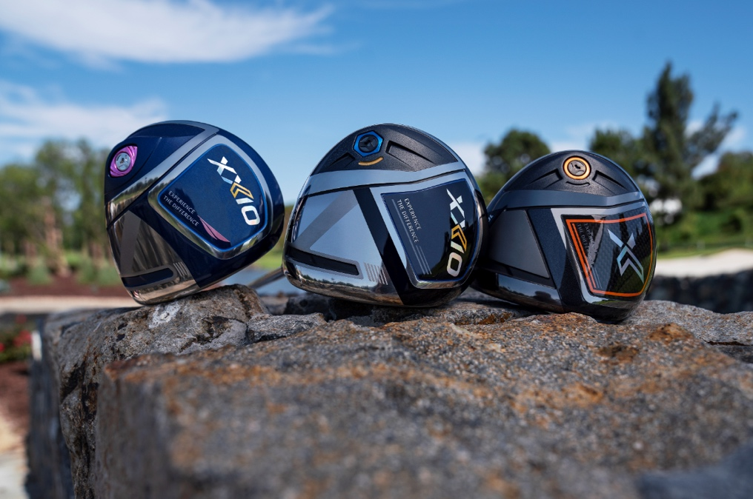
XXIO EUROPE - December 30, 2019 — XXIO®, a global leader in premium lightweight golf equipment, introduces the all-new XXIO Eleven and X golf clubs. Both families of golf clubs officially launch across Continental Europe on February 15, 2020.

“We’re different than any other brand in the market, just as our new tagline suggests, and in 2020, we’ll showcase our differences to more players than we ever have before,” said Lionel Caron, President of Srixon Europe. “We encourage all players to come out and ‘Experience the Difference’ of XXIO. My guess is that if you give us a try, you’ll see a ball flight that you haven’t seen in a very long time.”

WEIGHT PLUS
XXIO Eleven and X both feature XXIO’s new Weight Plus technology, which helps produce a more consistent and powerful swing. Weight Plus is a breakthrough achievement that pushes our high balance point clubs to the next level.

Weight Plus works by using up to 13g of brass and rubber weights placed in the butt end of every XXIO shaft. That mass behind the hands operates on the principle of a lever, assisting in the takeaway and reducing the effort required to swing each golf club.

XXIO ELEVEN MEN’S AND LADIES
For more than 10 generations, XXIO has focused on delivering real innovations and easier golf to moderate swing speed players.

With XXIO Eleven, a wholly redesigned cup face structure and profoundly lightweight shaft combines to produce fast, forgiving, and easy to swing golf clubs.

“We’ve been developing lightweight equipment for nearly two decades now,” Caron said. “That kind of experience gives you a real understanding of, not only the benefits of lightweight, but also the benefits of accompanying technologies that you can pair with lightweight to make the products perform even better. With our new Weight Plus counterbalancing technology, we are further pushing the limits of high balance point. It’s the combination of lightweight and high balance point that makes XXIO Eleven a game changer for moderate swing speed players.”

Below is a breakdown of the key technologies found within the full line of XXIO Eleven equipment that benefits the moderate swing speed player.
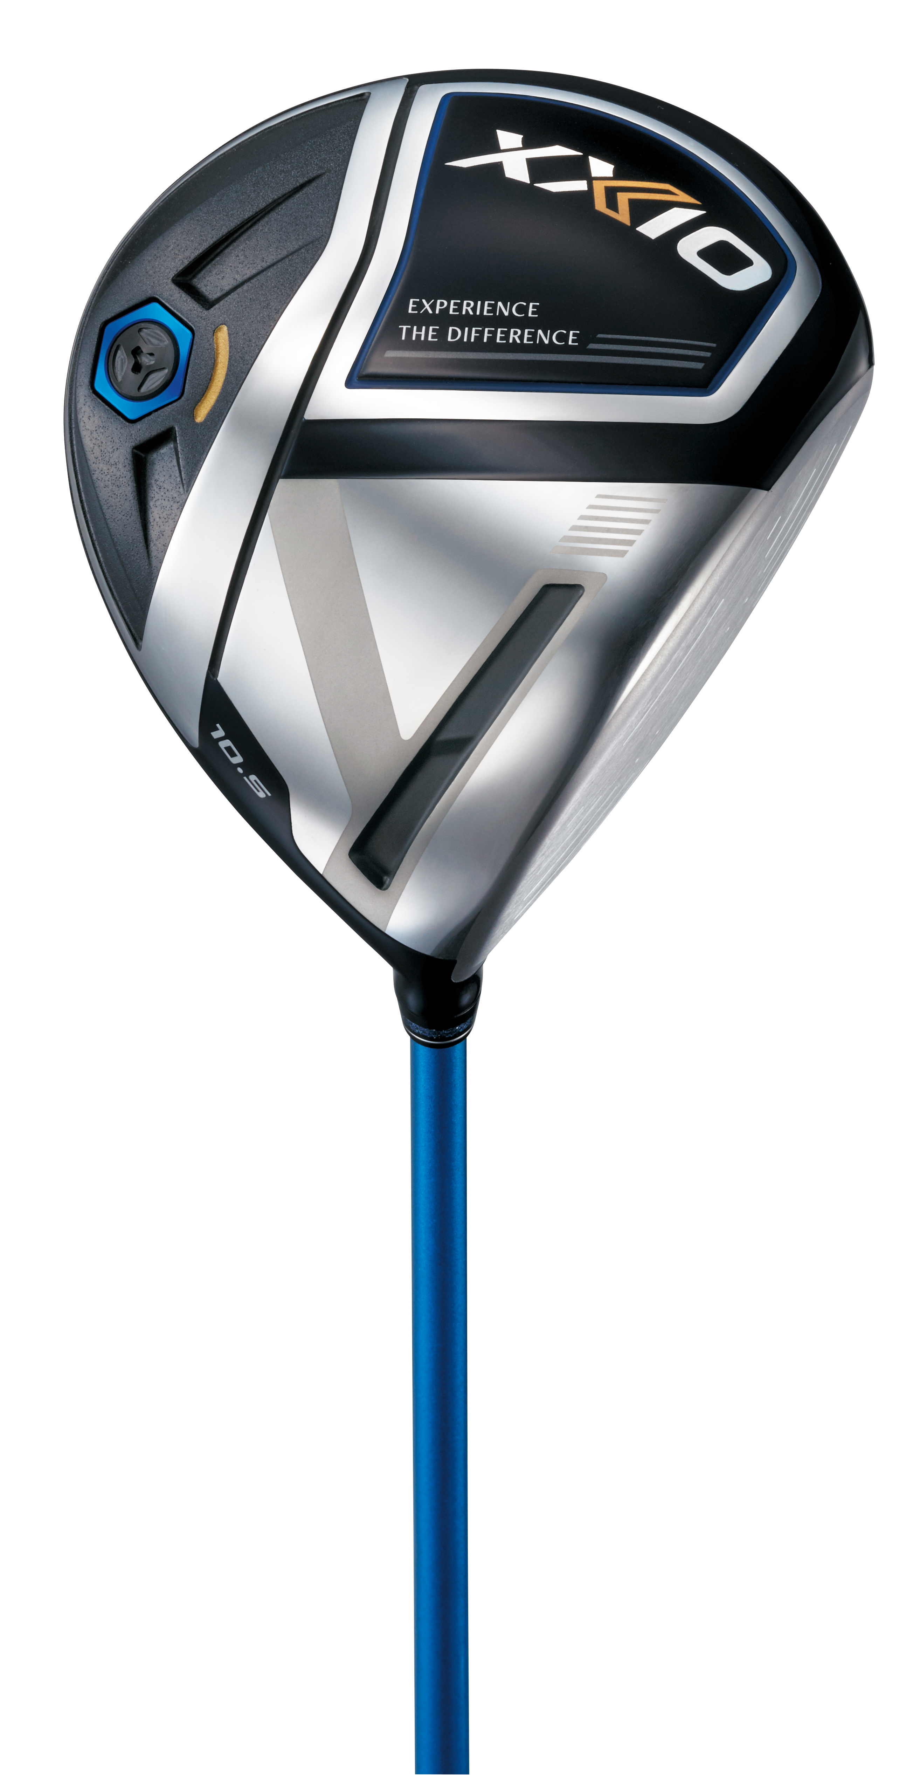
Key Technologies:
- Weight Plus: Brass and rubber weights in the butt-end of each club raise balance points to unprecedented heights. The effect is a smooth and easy swing that also helps you consistently find the ideal top-of-swing position for more power.
- Star Frame: XXIO Eleven’s Driver uses a Star Frame rib structure to support a sole thickness of just .45mm, redistributing weight for improved launch and forgiveness.
- Cup Face: XXIO Eleven’s Driver, Fairway Woods, and Hybrids feature a powerful yet normalized cup face that is fastest on center strikes and miss-hits alike.
- Cannon Sole: A uniquely shaped weight pad in the XXIO Eleven Woods and Hybrids creates space for a larger cup face, which in turn boosts speed and distance.
- Double Undercut Cavity: Two slots cut into the iron body just behind the face dramatically increase flexibility for explosive ball speed and distance.

XXIO Eleven Men’s and Ladies officially launch in Continental Europe on February 15, 2020, at an SRP of 240 €/264 CHF/2500 SEK for a single graphite iron, 349 €/389 CHF/3699 SEK for the XXIO Eleven Hybrids, 499 €/550 CHF/ 5299 SEK for the XXIO Eleven Fairway Woods and 749 €/825 CHF/7899 SEK for the XXIO Eleven Driver.

XXIO X-eks
The new XXIO X-eks model is a premium set of woods and irons that helps more accomplished golfers experience the benefits of lightweight and high balance point club design. The XXIO X-eks irons are forged in a more compact shape for enhance workability, while the driver features a carbon sole for a more muted sound a feel these golfers prefer.

“XXIO X-eks takes the same XXIO philosophy – lightweight and easy to swing – but is designed for better players” said Jeff Brunski, Vice President of Research and Development. “We’re targeting golfers who have typically played ‘players’ golf equipment, but are starting to see distance declines in their game.”

Below is a breakdown of the key technologies found within the full line of XXIO X-eks equipment.
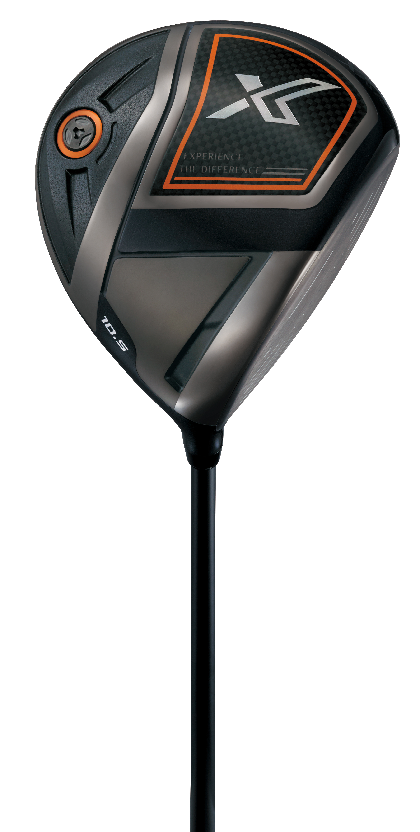
Key Technologies:
- Weight Plus: Brass and rubber weights in the butt-end of each club raise balance points to unprecedented heights. The effect is a smooth and easy swing that also helps you consistently find the ideal top-of-swing position for more power.
- Carbon Fiber Sole: XXIO X-eks’s Driver uses a lightweight carbon fiber sole to redistribute weight for improved launch and forgiveness.
- Cup Face: XXIO X-eks’s Driver, Woods, and Hybrids feature a powerful yet normalized cup face that is fastest on center strikes and miss-hits alike.
- Cannon Sole: A uniquely shaped weight pad in the XXIO X-eks Woods and Hybrids creates space for a larger cup face, which in turn boosts speed and distance.
- Speed Groove: XXIO X-eks Irons have a milled speed groove on the backside of their faceplate. This channel around the perimeter flexes at impact, rebounding added energy back into the ball for incredible distance.
“XXIO X-eks allows a wider audience to experience the difference of XXIO,” Brunski said. “It’s easy distance and easy forgiveness, built without sacrifices.”

XXIO X-eks officially launches across Continental Europe on February 15, 2020, at an SRP of 216 €/240 CHF/2300 SEK for a single steel iron, 349 €/389 CHF/3699 SEK for the XXIO X-eks Hybrids, 499 €/550 CHF/ 5299 SEK for the XXIO X-eks Fairway Woods and 749 €/825 CHF/7899 SEK for the new XXIO X-eks Driver.

XXIO GOLF BALLS
XXIO Eleven and X golf balls offer better performance for moderate swing speed players. These golf balls are crafted for the moderate swing speed golfer and reduce the shock of impact for enhanced comfort on all shots.

XXIO Eleven delivers an extremely soft feel with low spin and maximum distance off the tee. Meanwhile, X golf balls are designed for players with slightly higher swing speeds who benefit from more distance off the tee and additional spin when attacking the green.

XXIO Eleven golf balls are available in White, Pink, yellow & mix and XXIO X-eks golf balls are available in White & Lime Yellow at an SRP of 49,99 €/59,99 CHF/529 SEK.

All information, product manual and pics about are on these links, the Password is 150220 :
XXIO Eleven golf ball
XXIO X-eks golf ba
XXIO ELEVEN Men : Driver Fairway Hybrid Irons
XXIO ELEVEN Lady : Driver Fairway Hybrid Irons
XXIO X-eks : Driver Fairway Hybrid Irons

ABOUT XXIO®:
Based in Huntington Beach, CA, XXIO®, is part of the Sumitomo Rubber Industries, Ltd. family and enjoys a strong presence on competitive tours worldwide. The professional staff includes players such as Ernie Els and Inbee Park, as well as many others. XXIO®, with their long-standing tradition of premium golf clubs in Japan, brings the #1 golf brand in Japan to America. XXIO® is committed to providing "Tour-proven, premium golf equipment to passionate golfers seeking to improve their performance while enhancing their experience playing the game of golf.”

