CLEVELAND GOLF INTRODUCES FRONTLINE, A COMPLETELY NEW WAY
TO DESIGN A PUTTER

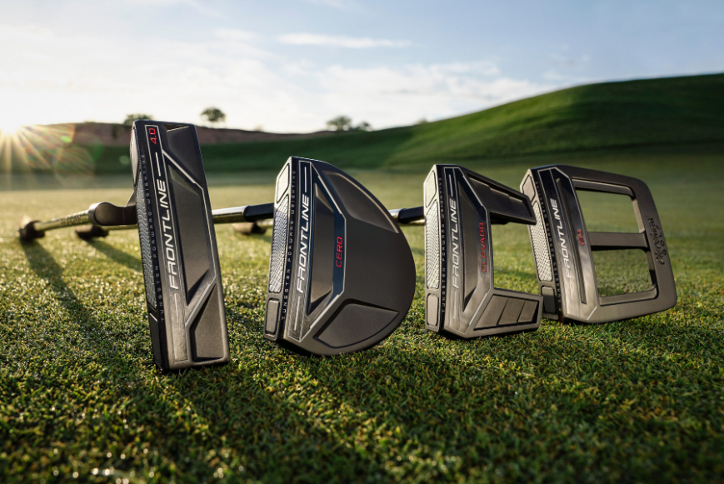
Saint Jean de Luz, France — 15th January, 2020 – Cleveland® Golf, where scoring matters, is proud to announce the release of Frontline. With a radical new weighting brings the center of gravity forward, Frontline provides a revolutionary process for engineering a putter. Frontline launches in Continental Europe on the 15th February, 2020.

“We are very excited about Frontline because it is a completely new approach to putter design,” said Lionel Caron, President of Cleveland Golf Europe. “By pairing an extreme center of gravity with an improved speed optimized face, we’ve designed a putter that uniquely maximizes directional and speed consistency. Combined with slick black cosmetics, great shapes and hosel options for different stroke types, Frontline really is the whole package.”

With Frontline, the challenge was creating a putter that’s powerful enough to counteract miss-hits and provide consistently straighter putts. The foundation of Frontline is Tungsten Forward Weighting, which places two Metal Injection Molded (MIM) tungsten weights in the face of the putter.

For decades, most mallets have weights in the rear of the putter to increase stability on off-center impacts, but this design places the center of gravity in the back of the putter. Frontline does the opposite, bringing the center of gravity forward for more accuracy on the greens.

Frontline features Cleveland’s Speed Optimized Face Technology (SOFT), which normalizes ball speed across the face for consistent distance performance on every putt. Every model in Frontline features an individualized SOFT pattern to help mitigate speed and distance loss, especially on off-center strikes.

Frontline offers three different mallet options that include Cleveland’s 2135 Technology to help with proper alignment when standing over that critical putt. Finally, Frontline offers two different hosel types to help provide a superior fit: single bend and slant neck. The single bend option is ideal for straight stroke types, while the slant neck option fits best for golfers with a slight arc stroke.

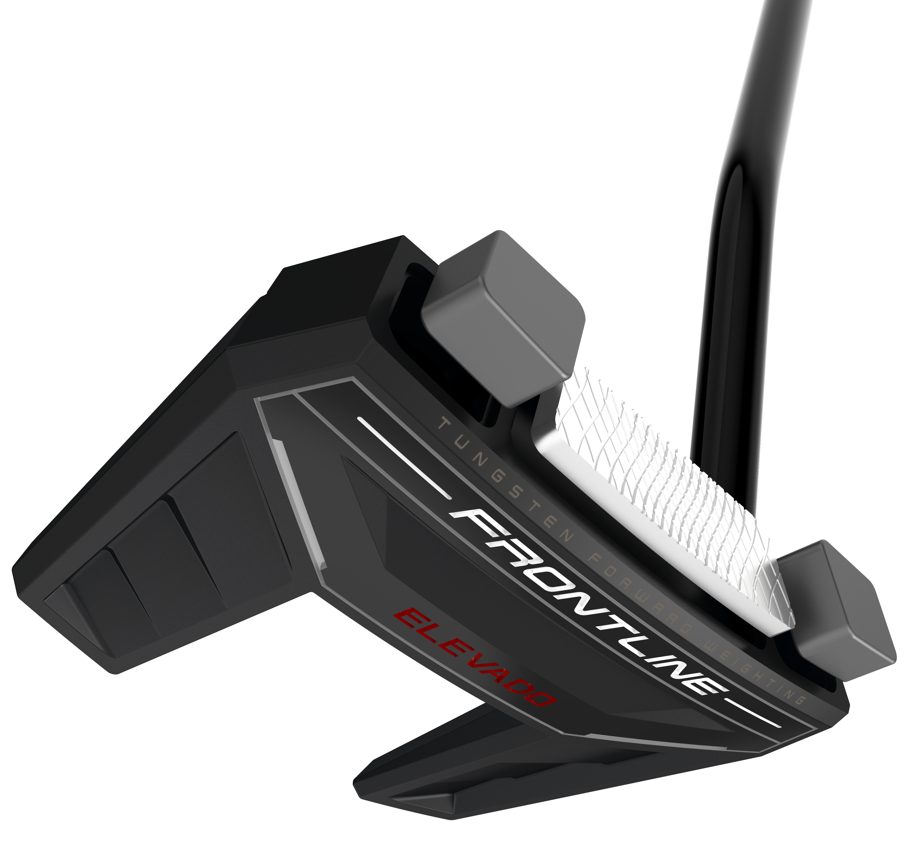
Key Innovations Inside Frontline:

- Forward Weights: With Tungsten Forward Weighting and the center of gravity positioned closer to the face, Frontline provides better stability through impact for straighter, more accurate putts.
- Speed Optimized Face Technology: Cleveland’s proprietary Speed Optimized Face Technology normalizes ball speed across the face, ensuring consistent distance performance on all your putts.
- 2135 Technology: Featured on the Elevado, Cero
and Iso models, achieve perfect alignment on every putt, regardless of where your eyes are at address.
- Additional Hosel Configurations: Find a superior fit with two different hosel configurations to suit every player’s stroke types.

Frontline comes standard with the Lamkin SINKFit Pistol Frontline grip and is available in 33”, 34”, and 35” length options. The Frontline 4.0 blade is €179/199 CHF/1899 SEK, while the three different mallet models (Elevado, Cero and Iso) are €199/219 CHF/2099 SEK. The Frontline Elevado, Cero and Iso feature single bend or slant neck hosel options.

For high-resolution images, the Frontline product manual, and other assets CLICK HERE.

Visit www.clevelandgolf.eu for more information on all Cleveland Golf products

Follow Cleveland Golf Europe on social media at:
Twitter: @ClevelandGolfEu
Facebook: @ClevelandGolfEurope
Instagram: @clevelandgolfeurope

Further information, images and media requests are available from James Lovett at Front 9 Group. Email: james@front9group.com / Tel: +44 (0) 7885599932

ABOUT Cleveland® Golf:
Based in Huntington Beach, CA, Cleveland® Golf is part of the Sumitomo Rubber Industries, Ltd. family and enjoys a strong presence on competitive tours worldwide. Their professional staffs include players such as Graeme McDowell, Keegan Bradley, Hideki Matsuyama, Inbee Park, as well as many others. Cleveland® Golf, founded in 1979, is a leading equipment manufacturer specializing in short game technologies and solutions that benefit all golfers. Cleveland® Golf remains steadfastly committed to providing "Tour proven, premium golf equipment to passionate golfers seeking to improve their performance while enhancing their experience playing the game of golf." For more information, please contact Noelle Zavaleta (714.889.5853) or visit us online at www.clevelandgolf.com.

