Media Contact:
James Lovett
07885599932
james@front9group.com

SINK MORE PUTTS WITH ADDITIONAL FRONTLINE MODELS FROM CLEVELAND GOLF
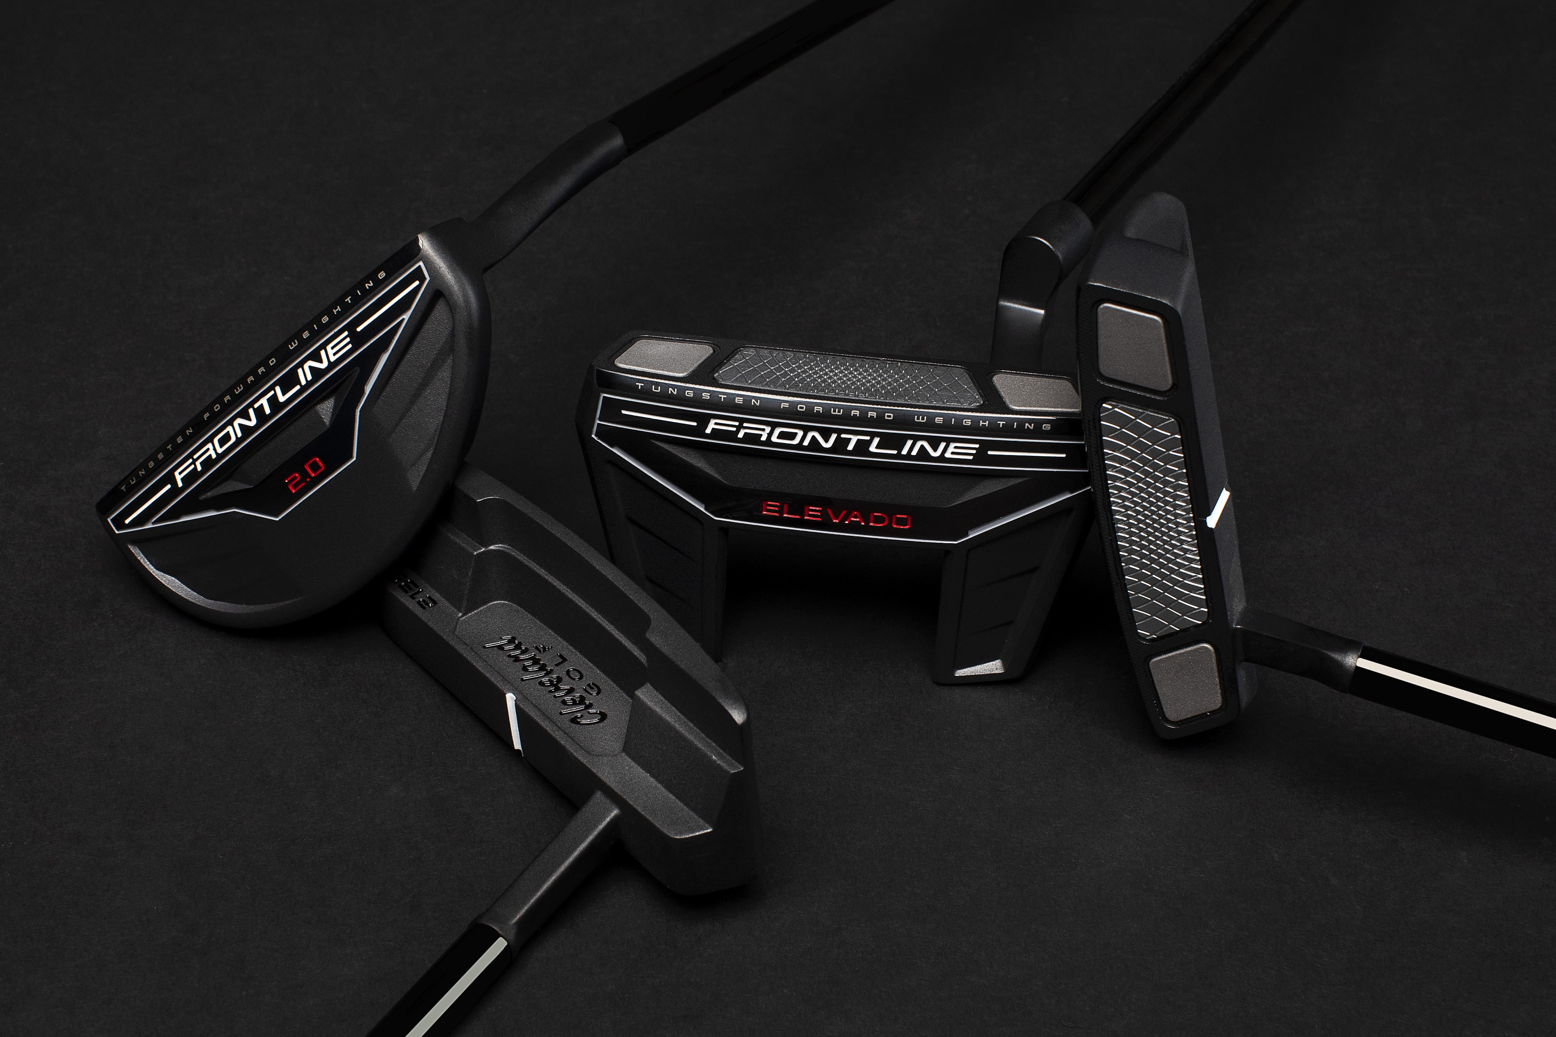
Cleveland Golf Europe - Golfers who enjoy straight putting will be excited to try Frontline from Cleveland Golf. Weights in the face have been shifted forward resulting in straighter putts, even when the sweet spot is missed. These golfers also enjoy better aim, more consistent distance, and a superior fit.

With an expanded lineup of designs and models to choose from, Frontline delivers a putter to fit any putting stroke and any player preference.

“Cleveland Frontline putters have changed how we think about weighting in putters,” says Joe Miller, Product Expert at Cleveland Golf Europe. “Having weight as close to the face surface as possible while maximizing MOI, provides the straightest putts on miss-hits ever measured. Frontline technology has eliminated the miss-hits. No matter where you hit on the insert, the ball will go straight and the same distance. This line-up, with additional models and builds, provides all options for players to uniquely align at impact. Delivering the face on the target line, while making the sweet spot ridiculously large, means more made putts.”

Frontline putters are made to fit any stroke. From single bend to slant necks and everything in between, there’s a Frontline model to fit every golfer’s game.

Retail Information and Pricing:

Pricing: Frontline Blade models are priced at £159 / €179 / CHF 199,99 / SEK 1,899.
and Frontline Modern Mallet Models are £179 / €199 / CHF 219,99 / SEK 2,099.

Additional Models: Frontline 2.0 Flow Neck, Frontline 8.0 Slant Neck/Single Bend, Frontline 10.5 Slant Neck/Single Bend, Frontline Elevado Plumber’s Neck

European Retail Launch Date: 20th March 2021
For high-resolution images, the Frontline product manual, and other assets CLICK HERE.

ABOUT Cleveland® Golf:
Based in Saint-Jean-de-Luz, France, Cleveland® Golf Europe is part of the Sumitomo Rubber Industries, Ltd. family and enjoys a strong presence on competitive tours worldwide. Their professional staff players include, Shane Lowry Graeme McDowell, Keegan Bradley, Hideki Matsuyama, Inbee Park, as well as many others. Cleveland® Golf, founded in 1979, is a leading equipment manufacturer specializing in short game technologies and solutions that benefit all golfers. Cleveland® Golf remains steadfastly committed to providing "Tour proven, premium golf equipment to passionate golfers seeking to improve their performance while enhancing their experience playing the game of golf." For more information visit us online at www.clevelandgolf.eu.

