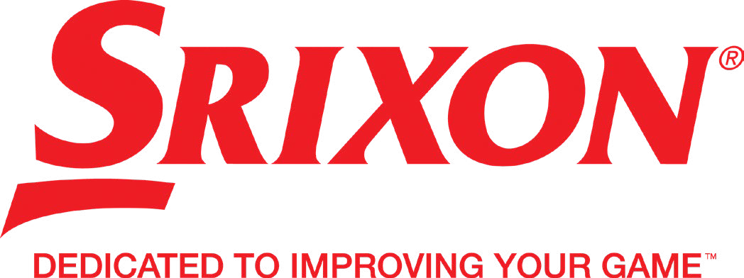
For more information on all products in the Srixon Golf 2022 range, visit www.srixoneurope.com or www.srixon-share.com

Media Contact:
James Lovett – Front 9 Group Contact: 07885599932
E-Mail: james@front9group.com

For immediate release.

SRIXON ANNOUNCES THE FOURTH GENERATION

ULTISOFT GOLF BALL
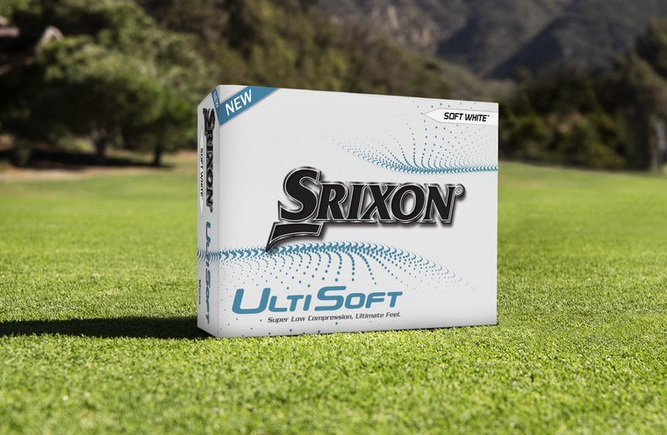
5th August 2022
Srixon Sports Europe, Saint-Jean-de-Luz, France, SRIXON®, a global leader in golf ball technology and innovation, announces the fourth generation UltiSoft golf ball, the lowest compression golf ball in our lineup.

The UltiSoft lives up to its namesake as the ultimate golf ball for softness and feel. The foundation of the all-new UltiSoft is the FastLayer Core technology, a unique design that adds distance while maintaining that signature feel. Its powerful distance with maximum softness on every strike.

UltiSoft features a 338 Speed Dimple pattern to help reduce drag and increase lift. These Speed Dimples improve overall aerodynamics for better performance with drivers, woods, and irons.
Get ultimate softness and ultimate feel with the fourth generation UltiSoft.

Key Technologies:
- FastLayer Core: With a soft center that gradually transitions to a firm outer edge, the FastLayer Core gives UltiSoft incredible softness and great distance off the tee.
- Soft, Thin Cover: Provides more greenside spin and softer feel on all pitches, chips and putts.
- 338 Speed Dimple Pattern: To get more distance overall and better performance in the wind, Speed Dimples reduce drag at launch and increase lift during descent.

Retail Information and Pricing:

EUR| 28.00
CHF| 32.00
SEK| 299.00

Launch into stores: 17th August 2022
Colour Offerings: Pure White

For media assets and full product information, click here.

ABOUT Srixon®:
Based in Saint-Jean-de-Luz, France, Srixon Sports Europe®, is part of the Sumitomo Rubber Industries, Ltd. family and enjoys a strong presence on competi- tive tours worldwide. The professional staff includes players such as Shane Lowry, Hideki Matsuyama, Graeme McDowell, Keegan Bradley, Inbee Park, as well as many others. Srixon®, with more than 80 years of golf ball manufacturing experience, is committed to providing “Tour-proven, premium golf equipment to passionate golfers seeking to improve their performance while enhancing their experience playing the game of golf.”

