Media Contact:
James Lovett
07885599932
james@front9group.com

FOR IMMEDIATE RELEASE
CLEVELAND GOLF INTRODUCES TWO ADDITIONAL
HB SOFT PUTTER LINES

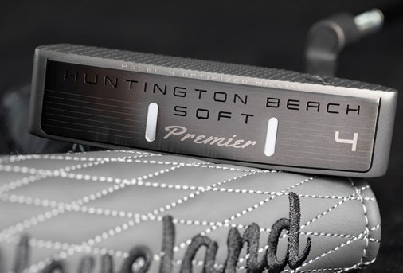
8th February 2021
SSE Alton, UK: – Cleveland Golf® is proud to announce the new Huntington Beach SOFT Premier putters, to go along with an array of new Huntington Beach SOFT models. Discover a new, premium putting experience and the confidence to sink more putts with the new Huntington Beach SOFT Premier, officially launching into stores on 20th March 2021.

“The Huntington Beach SOFT Premier builds upon the success of our current putter line-up,” said Joe Miller, Product Expert at Cleveland Golf Europe. “With new head shapes, sleek designs, and a fitting system for every stroke type, we have a putter that will help any golfer improve their performance on the greens.”

The foundation of the Huntington Beach SOFT Premier is Cleveland Golf’s proprietary Speed Optimized Face Technology (SOFT). SOFT solves the crucial putting issue of distance control. SOFT normalizes the speed of putts across the entire putter face.

The centre of the face features more condensed milling lines, while milling mark frequency decreases going outward from the centre. Unlike similar technologies featured elsewhere, SOFT takes the next step by delivering model specific milling for each model, so we can deliver optimized distance control regardless of the putter shape.

Huntington Beach SOFT Premier features two specific putter grips to achieve optimal putting performance for each stroke type. For slight or strong arcing strokes, the Lamkin SINKFIT Skinny Pistol grip, combined with a toe-down weighting, will help facilitate clubhead rotation. Meanwhile, the larger Lamkin SINKFIT Pistol grip and face-balanced design is ideal for straight back stroke types.

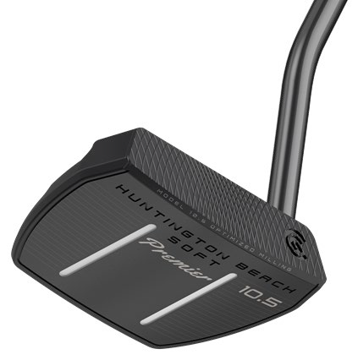
Media Contact:
James Lovett
07885599932
james@front9group.com

FOR IMMEDIATE RELEASE
Key Innovations Inside Huntington Beach SOFT Premier:
- Grey Satin Finish: Sleek, Grey Satin PVD finish delivers a premium appearance and instils a sense of confidence.
- Speed Optimized Face Technology: Ensuring consistent speed control and distance performance, Cleveland’s proprietary Speed Optimized Face Technology normalizes ball speed across the entire face of the putter, even on off-centre putts.
- Putting Fit System: With two different grip options, the new Huntington Beach SOFT Premier offers a precise fit depending on your stroke type and model preference.
- Precision Milled Face: A unique diamond CNC milling

pattern increases friction for a pure roll and softer feel at impact.

Furthermore, Cleveland Golf is introducing eight new tour-proven shapes to the Huntington Beach SOFT collection. These new releases offer a similar fitting system.

For slight or strong arc types, the Huntington Beach SOFT Pistol grip comes standard, while straight back stroke types will benefit from the Huntington Beach SOFT Oversized grip.

For high-resolution images, product manuals and other assets CLICK HERE.

Retail Information and Pricing

Huntington Beach SOFT Premier putters are available for £139/ €149, while the new models of Huntington Beach SOFT putters are available for £119/ €129.

For more detailed information on the new Huntington Beach SOFT Premier putters, please visit: www.clevelandgolf.co.uk.

ABOUT Cleveland® Golf:
Based in Alton, UK, Cleveland® Golf Europe is part of the Sumitomo Rubber Industries, Ltd. family and enjoys a strong presence on competitive tours worldwide. Their professional staff players include, Shane Lowry Graeme McDowell, Keegan Bradley, Hideki Matsuyama, Inbee Park, as well as many others. Cleveland® Golf, founded in 1979, is a leading equipment manufacturer specializing in short game technologies and solutions that benefit all golfers. Cleveland® Golf remains steadfastly committed to providing "Tour proven, premium golf equipment to passionate golfers seeking to improve their performance while enhancing their experience playing the game of golf." For more information visit us online at www.clevelandgolf.co.uk.

