SRIXON INTRODUCES Q-STAR TOUR DIVIDE:
START SEEING DOUBLE

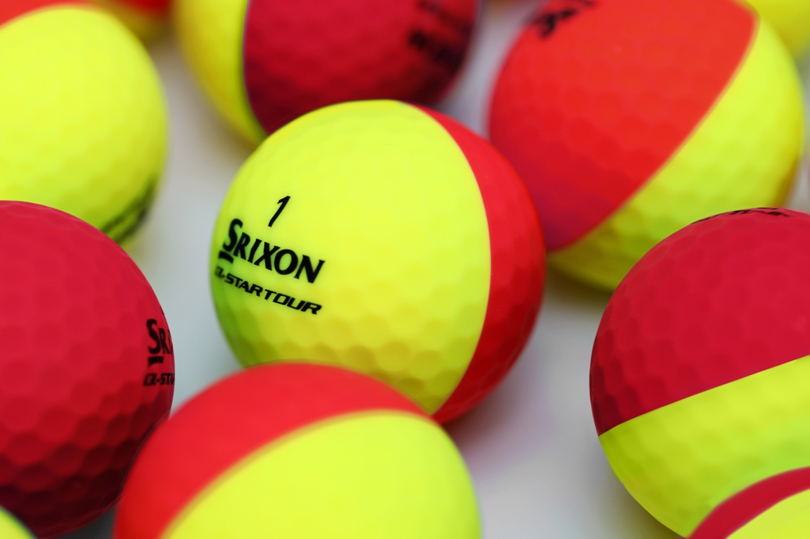
Srixon Sports Europe - Alton, UK — SRIXON®, a global leader in golf ball technology and innovation, announces the all-new Q-STAR TOUR DIVIDE. This exciting new golf ball offering from Srixon officially launches in The UK & Ireland on the 15th July 2021.

“The new Q-STAR TOUR DIVIDE looks great, but it’s so much more than that,” explains Joe Miller, European Product Manager. “Easier putting alignment and increased visual feedback on your chip and pitch shots really adds to the greenside performance. It’s a ball every golfer must try.”

The Q-STAR TOUR DIVIDE is different, featuring a new thermoplastic urethane cover that has been infused with bright pigments rather than being painted on. The 50/50 Matte Urethane Cover delivers a high contrast, matte cover that provides the same tour-level spin and stopping power you’ve come to expect from the original Q-STAR TOUR.

With DIVIDE’s unique two-tone cover construction, putting alignment comes easy with a 360° line, while every shot will produce a strobe effect to help show off the speed and direction of spin.

DIVIDE might not look like a classic golf ball, but it still delivers true tour performance. Featuring the same FastLayer Core and 338 Speed Dimple Pattern found on the classic Q-STAR TOUR, DIVIDE provides the distance and control expected from a tour-caliber golf ball.

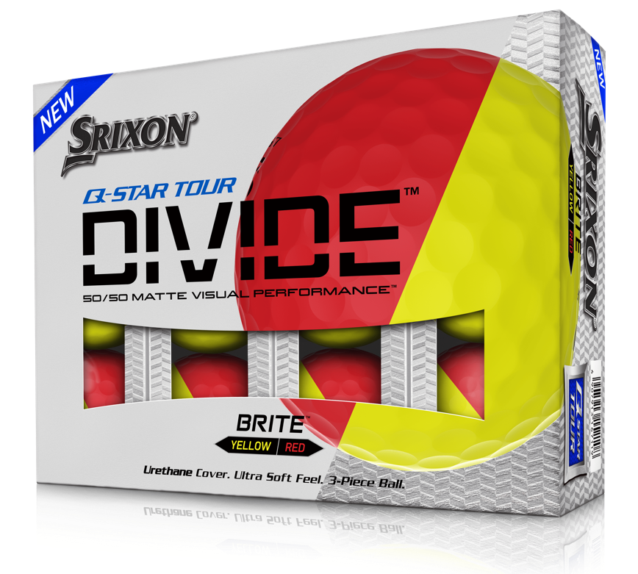
Key Technologies Inside Q-STAR TOUR DIVIDE:
- New FastLayer Core: The new FastLayer Core offers distance and soft feel without compromise due to a gradual transition from soft inner core to firm outer edge.
- 50/50 Matte Urethane Cover: The high contrast, matte cover makes spin visible and putting alignment easy. It’s cast from soft urethane for tour-level spin and stopping power.
- 338 Speed Dimple Pattern: Providing a penetrating ball flight in any conditions, the 338 Speed Dimple Pattern increases lift and reduces drag to maximize distance.

For high-resolution images, the Q-STAR TOUR DIVIDE Product Sales Sheet, and other assets CLICK HERE.

Retail Information and Pricing:
Price: £34.99/ €40
Available in the following colours: Yellow/Red, Yellow/Blue & Yellow/Orange.
UK & Ireland Retail Launch Date: 15th July 2021.
For more information on all products in the Srixon range, visit www.srixon.co.uk or explore our Srixon Share portal www.srixon-share.com

